**Political Mind Mapping**

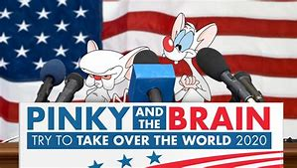Americans are raised on certain core values and identifiers that define our political views and ideology. We see public policies as benefiting one group or hurting another based on our political culture and therefore we vote on those perceptions. We further use political parties to help identify which public policy and candidates fit our core values.

*Assignment:* Annotate the Political Mind

Political parties are always trying to decipher the political leanings of Americans. They have even gone as far as identifying our political leanings based on the products, we consume. They are really trying to read the alpha waves of our brain to tailor public policies to our desires and win elections. You are going to design a public policy brain for assigned ideology to illustrate how a particular ideological demographic views public policy.

*Requirements:*

* Reflect the profile of the stereotypical demographic based on assignment
* 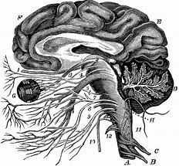Use actual public policies to support your conclusions
* Define and explain clear cut public policy views for the assigned demographic based on the following
  + Economic Public policy
    - Economic theory
    - Fiscal policy and monetary beliefs
    - Taxation & government spending
    - Fiscal Federalism
    - Regulation vs. Deregulation
    - Environment or Global Warming
  + Social Policy
    - Social Welfare – Medicare, Medicaid, social security
    - Civil Rights & Equality
    - 2 Personal Liberty
* Develop a slogan that summarizes their public policy views and ideology
* Identify and explain which political party your demographic would support
* Identify and explain which current candidate running in 2020 they would like support
* Use images within the brain to represent views

Demographics:

* White male - White female - African American
* Protestant - Latino - Blue Collar Laborer
* Poor - Wealthy - Elderly

Assignment due date:

