**To be or not to be an American**

*Directions:* Answer the prompt by demonstrating how much colonists in America have become separated from their English brethren. Use facts and short descriptions to illustrate your conclusions. (Must include 10 support facts and 5 counter facts.)

**Prompt:** *America’s and England’s relationship during the early half of the 18th century was based on the belief that colonists thought they were English citizens and economic equals. To what extent did America’s connection to its English’s mother dissipate during the 18th century?*

Thesis: ________________________________________________________________________________________

______________________________________________________________________________________________

______________________________________________________________________________________________

Historic Contextualization Paragraph:

**AMERICAN ENGLISH**

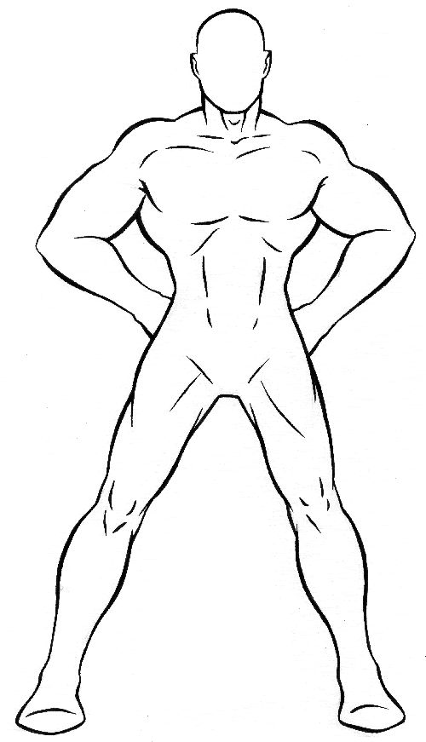

**Profile the American Colonies**

Assignment: Construct a profile of the American colonies that analyze the transition that is occurring in the colonies of how colonists were changing from being English to becoming American.

Profiling the American Colonies

|  |  |  |
| --- | --- | --- |
|  | American | English |
| Political |  |  |
| Economic |  |  |
| Religious |  |  |
| Social |  |  |
| Intellectual |  |  |
| Area |  |  |