|  |  |  |  |  |
| --- | --- | --- | --- | --- |
|  |  | |  | | --- | | Doris Henderson Newcomers School Middle School Newsletter 2017-18 | | Se | |
|  |  |  |
| Have a fall-Tastic NOvember!!! |  |  |

**Character Education**

**The trait for the month of November is KINDNESS. Talk to your child about being kind one another.**

**Important Dates to Remember:**

**Nov. 08th – Early Release Day for students**

**Nov. 10th – Holiday – No school for students**

**Nov 22nd – Vacation – No school for students and teachers**

**Nov. 23rd and 24th – Holiday – Thanksgiving – No school for teachers and students**

**Nov. 27th - Report Cards go home**

**Homework:**

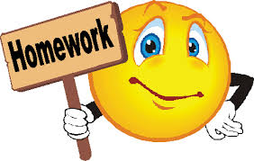

Students will be assigned homework every day, except for Fridays. Please make sure your child completes his/her assignments daily.

**MATH: **

**In math, we will be learning the following skills:**

**6th: Ratios and Proportions**

**7th:  Algebraic Expressions and Equations**

**8th grade:  Rational Numbers, Square Roots, and Exponents.**

**SCIENCE:** In 8th grade Science, we are learning about ecosystems during the month of November.  In 7th grade Science, we are finishing our unit on different types of energy and beginning our unit on cells.  In 6th grade Science, we are finishing the content about energy waves.



We are also starting a new Energy Wise club in middle school.  The students on the team have chosen the name "Newcomers Energy Club."  We meet twice a month and work on projects to help our school and families save energy.

**SOCIAL STUDIES: This month, 6th, 7th, and 8th grade students will be reading assorted biographies. They will analyze the impact of many important leaders in our society and world.**

**ELA : The theme we will begin in November is social change heroes.  Your students will be reading about great leaders such as Martin Luther King Jr., Ruby Bridges, Mohandas Ghandi, and Cesar Chavez.  We will cover the genres of biography and autobiography.  Students will study the present progressive verb tense, and they will apply this tense to their original writing.  Students will continue writing narratives, and they will practice writing narratives with different points of view.**

**LITERACY: In November, we are beginning to use our reading strategies independently.  We are working to use the pictures with sentences to understand what we read.  We will learn how to use text evidence to answer questions.  We can tell our answers orally or write a sentence to show our answer.**

**PHYSICAL EDUCATION: In P.E., students will be transitioning from volleyball skills to basketball skills.**

**MEDIA CENTER:** We have lots of great participation in getting our school Reader Leader reading logs filled out. Keep up the good work, everyone! New Reader Leader reading logs for our 2nd semester will be given out to students at the beginning of November. Don’t forget to read every night for 30 minutes.

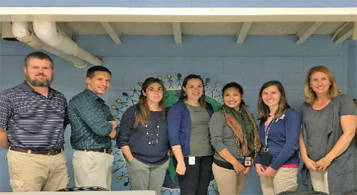

**Homeroom teachers from left to right:**

**Mr. Jordan, Mr. Wolak, Mrs. Hudak, Mrs. Polito, Mrs. Shornack, Mrs. Cox, and Mrs. Humphrey**

**Contact Information:**

**Literacy 7-8 –** Mrs. Cox[**coxa3@gcsnc.com**](mailto:coxa3@gcsnc.com)

**Literacy 7-8** – Mrs. Humphrey [**humphrj@gcsnc.com**](mailto:humphrj@gcsnc.com)

**Literacy 6-8**– Mrs. Hudak [**hudakk@gcsnc.com**](mailto:hudakk@gcsnc.com)

**Literacy 6-8 – Mrs. Polito** [**politoc@gcsnc.com**](mailto:politoc@gcsnc.com)

**Science** **6-8**– Mr. Jordan [**jordanb2@gcsnc.com**](mailto:jordanb2@gcsnc.com)

**Social Studies 6-8** – Mrs. Shornack [**shornaa@gcsnc.com**](mailto:shornaa@gcsnc.com)