Homework Assignment Due ______________ U2 Ch. 7 Comparisons of Exchange pp. 127-132

You will choose ONE of the following tasks. A Grading Rubric follows.

You must include this in your task:

|  |
| --- |
| 3 similarities and 3 differences among the various networks of exchange in the period from 1200-1450. Identify ONE reason for a similarity and ONE reason for a difference |

**Task BLUE: Write a 3-paragraph essay**

**Task White: Prepare a graphic organizer**

Rubric Grade range *within* a letter is for Quality, Originality, and other ineffable traits

|  |  |  |
| --- | --- | --- |
|  | CONTENT | PRESENTATION |
| A- 90-100 | All requirements present & correct | Superbly neat, organized, and is 90% + grammatically correct |
| B- 80-89 | Missing 1 requirement | Very neat, organized and is 80% grammatically correct |
| C- 70-79 | Missing 2-3 requirements | Neat, organized and is 70% grammatically correct |
| D- 60-69 | Missing 4 requirements | Messy, poorly organized and is 60%  Grammatically correct |
| F- 50-59 | Missing 5 requirements | Messy, disorganized and a grammatical disaster |
| RE-DO | Missing 6 + requirements | Messy, disorganized and a grammatical disaster |

[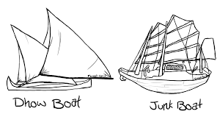](https://www.google.com/imgres?imgurl=https%3A%2F%2Fi.pinimg.com%2Foriginals%2Fa0%2Fa3%2F77%2Fa0a377fb35eaf27ae21f498d7be332a8.png&imgrefurl=https%3A%2F%2Fwww.pinterest.com%2Fpin%2F7740630594961473%2F&docid=zVqKJXfnTx1-hM&tbnid=AwuGuvEWFjtjnM%3A&vet=10ahUKEwjN2YXxxaHlAhViu1kKHdJAB_gQMwhlKAkwCQ..i&w=1061&h=610&bih=682&biw=1264&q=dhows%20and%20junks&ved=0ahUKEwjN2YXxxaHlAhViu1kKHdJAB_gQMwhlKAkwCQ&iact=mrc&uact=8)[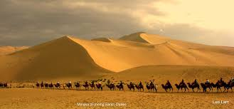](https://www.google.com/imgres?imgurl=https%3A%2F%2Flive.staticflickr.com%2F3532%2F3232808903_7c99153f78_b.jpg&imgrefurl=https%3A%2F%2Fwww.flickr.com%2Fphotos%2Fleo_lam_2000%2F3232808903&docid=dCi5Hy8E1ic1FM&tbnid=t3Sra6VPJaed9M%3A&vet=10ahUKEwie1-CLxqHlAhUqx1kKHS2qDJcQMwhzKBEwEQ..i&w=1024&h=477&safe=strict&bih=682&biw=1264&q=camels%20silk%20road&ved=0ahUKEwie1-CLxqHlAhUqx1kKHS2qDJcQMwhzKBEwEQ&iact=mrc&uact=8)

[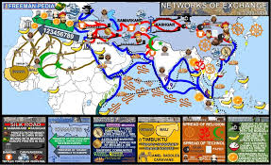](https://www.google.com/imgres?imgurl=https%3A%2F%2Fimages.squarespace-cdn.com%2Fcontent%2Fv1%2F53b17013e4b0f83f2d8a8a4a%2F1562162699057-QOUQXYA9EKZSAU7ZS9NO%2Fke17ZwdGBToddI8pDm48kEJIop0Ls6nfv0VCBk2y6mYUqsxRUqqbr1mOJYKfIPR7LoDQ9mXPOjoJoqy81S2I8N_N4V1vUb5AoIIIbLZhVYy7Mythp_T-mtop-vrsUOmeInPi9iDjx9w8K4ZfjXt2dsO3s0GUGQMm46r1dCPLLBiUhUCR0MUMxTMY84MrosspJvwGh1qtNWvMhYKnvaKhbA%2FNETWORKS%2BOF%2BEXCHANGE%2BMAP%2BAP%2BWORLD%2BHISTORY%2BMODERN%2BFREEMANPEDIA.JPG&imgrefurl=https%3A%2F%2Fwww.freeman-pedia.com%2F2-networks-of-exchange-12001450&docid=aTwckHOnepZ9nM&tbnid=z1izjl0u72zPlM%3A&vet=10ahUKEwjdwfmgxqHlAhUq1VkKHR-fA-kQMwhMKAAwAA..i&w=1000&h=611&safe=strict&bih=682&biw=1264&q=networks%20of%20exchange%201200-1450&ved=0ahUKEwjdwfmgxqHlAhUq1VkKHR-fA-kQMwhMKAAwAA&iact=mrc&uact=8)