

*How to Reach Me*

E-mail [williaa14@gcsnc.com](mailto:williaa14@gcsnc.com)

Remind @lookoutela (Sign up for updates on homework, tests, quizzes, & important dates)

Phone [(336) 674-4280](javascript:void(0))

**1st Infraction:** Verbal/Documented Warning

**2nd Infraction:** Verbal/Documented Warning & parent contact

**3rd Infraction:** Detention & Office Referral

*Rules & Expectations*

***S***how Respect: Be on time, listen while others are talking

***E***xercise Integrity: Bring your best attitude

***M***aintain Self-control: Be friendly and respective

***S***eek Excellence: Be attentive and engaged

*Class Materials*

*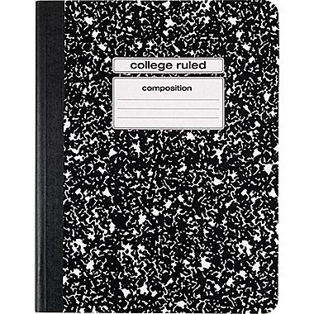or 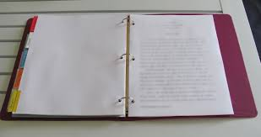 for notes*

*Pencils/pens*

*Laptop*

*USB flash drive*

*Notecards*

*Sticky Notes*

*High lighters*

*Grades* 

***50% Academic:*** *Classwork, participation, homework, warm-ups/cool down, station work*

***50% Assessment:*** *Quizzes, Tests, Projects*

*__________________________________*

☺ Tutorials: Mondays & am upon request

☺ Retake Assessments: 2 assessment re-takes total, must come to tutorial with retake note.

☺ Late work: is a zero until work is submitted.

*Absences*

Immediately upon, return receive notes from classmate and any missing assignments. You have up to 3 days to turn-in make-up work to receive a grade.