Scramble for Africa Simulation – Teacher Directions

**National Delegate Assembly**

* Divide students into five groups regardless of class size. Each group will represent one of the five core countries that attended the Berlin Conference in 1884-1885.
* Handout the Maps Packet (p. 10-13), Nation Briefing Sheets (p. 3-7), and Delegate Proposal Map (p. 8) to each National Committee. Explain that as a group they should identify the nations and regions that would best meet their needs. They should color the map accordingly taking into account national interests, ease of governance, competition with other European powers, etc.
* By the end of the National Delegate Assembly, each member should have their ideal territories colored in and have relatively identical maps.

**Berlin Conference**

* Cut apart the CHANCE cards prior to the simulation (p. 14)
* Divide the students into groups of five, one delegate from each nation and handout one copy of the Berlin Conference map (this is best copied onto a 11x14 sheet of paper)
  + **Step 1** – Students should proceed to label every country on the map with an abbreviation of their country’s name (GB, F, P, B, and N work best) so that regions/nations in dispute can readily be identified. Make sure they do this in pencil.
  + **Step 2** – After the initial claims have been made, draw TWO chance cards and read them aloud. Adjustments must be made to the map and kept through the end of the simulation.
  + **Step 3** – Students should begin the negotiating process. Students should negotiate one region at a time (West, East, Central, South, North). By the end of the first round, two regions must be entirely claimed. Countries that have not been agreed upon, are ceded back to Africa and will be sources of future European conflict. Set a timer for 10 minutes and display it at the front of the room.
  + **Step 4** – Draw TWO more chance cards and read them aloud. Adjustments must be made to the map and kept through the end of the simulation regardless of the original agreements that were made.
  + **Step 5** – Provide another 10-minute period for the students to negotiate two other regions. No other changes can be made to completed areas unless the chance cards required them.
  + **Step 6** – Draw TWO more chance cards and read them aloud. Adjustments must be made to the map and kept through the end of the simulation regardless of the original agreements that were made.
  + **Step 7** – During the final round, make any last adjustments to the final region. Color the map as necessary to define the final boundaries

**Debrief**

* Display the Berlin Conference Map (p. 15) and ask students to compare their maps with the real result.
  + How are they different?
  + What factors did you consider in the conference?
  + How did the CHANCE cards affect the outcome?
  + Who would be considered the winner of Berlin Conference? Why?
  + What impact do you think these boundary divisions had on Africa?

Student Directions

During the centuries following the European arrival in the Americas, the world has undergone drastic changes as nations, peoples, religions, and economies have both integrated and disintegrated. The New World has now been conquered with a newly independent United States of America, Spanish and Portuguese colonies across Latin America and British colonies in Canada. The last remaining “unexplored” region was the interior of Africa, but with the financial support of King Leopold II, Henry Morton Stanley has removed the last *terra incognita* from the map.

In order to avoid the colonial warfare that plagued the New World and Asia, you have been called together by Otto von Bismarck, the first Chancellor of Germany, to formalize the division of Africa amongst the European powers. This General Act of the Berlin Conference seeks to create substantive boundaries between these nations that reflect the economic and political interests of its member states.

Today you will represent your nation and these very interests to carve up Africa and bring them into the modern, European world!

---------------------------------------------------------------------------------------------------------------------------------------------------

**PART 1 – NATIONAL DELEGATE ASSEMBLY**

* Within your assigned groups, read the background briefing of your given country. Using this information and the colored map handouts, identify the division of Africa that would best meet your colonial interests on your own map. You may color or write in country names.
* Within your delegate assembly, compare and contrast the potential boundaries. Identify changes or rationales as to why you should claim any of these areas. Base your information on the maps provided. Adjust your map as needed.

**PART 2 – DELEGATE NEGOTIATIONS**

* You will be divided into groups to negotiate the division of Africa. During this meeting you should:
  + Negotiate in your country’s best interest
  + Prevent other countries from getting too powerful
  + Create informal negotiating alliances to come to a consensus
* During each round, you will negotiate for specific regions and have to deal with unexpected demands through the introduction of CHANCE cards read by the teacher.
* Write only in pencil so that changes can be made if necessary either through negotiations or CHANCE cards.
* By the end of the conference time, the continent must be divided entirely. Any space leftover will be considered indigenous nation-states.
* Additional Issues
  + Each representative must come away with at least one new nation
  + Newly drawn borders need not reflect cultural, religious, ethnic, or linguistic boundaries.
* During the final negotiation, color the map accordingly
  + Great Britain – Blue
  + France – Red
  + Netherlands – Green
  + Portugal – Purple
  + Belgium – Yellow
  + Indigenous Nations/CHANCE Nations – Orange

Belgium – Nation Briefing

Newly formed after a revolt from the Netherlands in 1830, Belgium leapt to the forefront of the Industrial Revolution. With coal readily available, blast furnaces and railways quickly spread across the country, but the nation lacked many of the natural resources found by other colonial powers, particularly copper. Also, while the military swelled during the Franco-Prussian War (1870-71), they are unable to compete territorially with the great powers of Europe, leaving trade and diplomacy their main means of leverage.

Recently, King Leopold II funded the exploration of the interior of Africa as a means to find new trading partners and resources. Along with the International African Association, new inroads have been made towards colonizing Central Africa, but the Berlin Conference is critical to maintaining this new imperial destiny.

**Conference Goals:**

* Exclusive control and access to the Congo region of central Africa
* Access to gold and diamond deposits found in southern Africa
* Territorial expansion so you’ll be taken seriously by other European powers

.

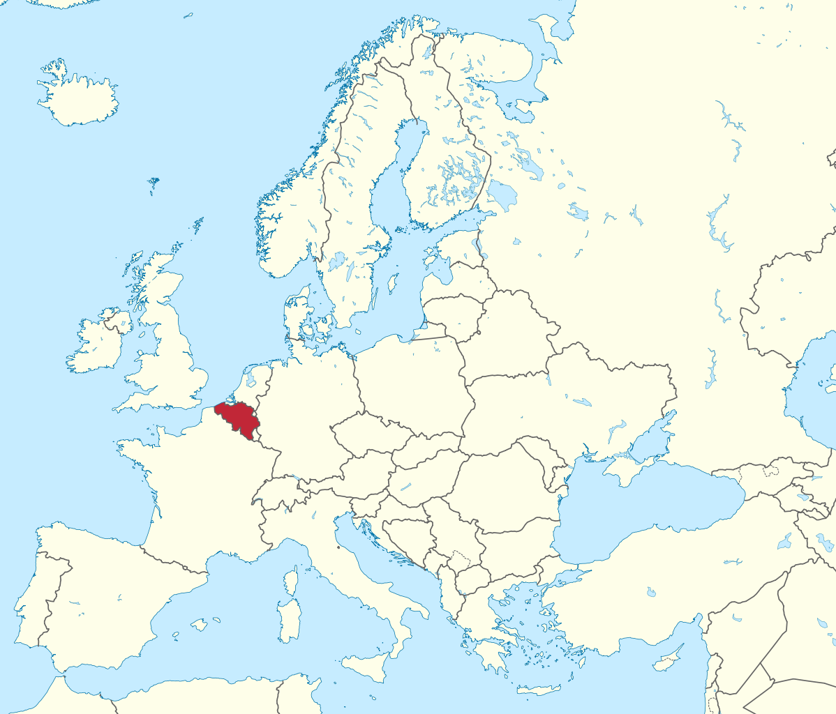

France – Nation Briefing

Following the defeat of Napoleon, the Bourbon Restoration, and various civil wars, France has emerged during the Third Republic. Now with a relatively stable government, industrialization has reinvigorated the nation’s powerful navy and army. This in turn has allowed for France to expand colonial possessions, particularly in Southeast Asia, but now Africa remains. Despite years of conflict with its eternal neighbor, Great Britain, your nation sees the Berlin Conference as a means to cement your political position in the region, and to offset the growing power of a newly minted Germany.

Africa is not a new venue for French involvement. The northern nation of Algeria has been critical to French expansion and attempts by Napoleon III were made to make the nation a model of French/Arab cooperation. Now is the chance though for this influence to expand even further, establishing a Francophile sphere of influence across the Mediterranean Sea.

**Conference Goals:**

* Expansion of French control along the Mediterranean region and western coast of Africa
* Access to trade goods such as rubber, cotton, tropical hardwoods, palm oil, and cocoa.
* Access to gold and diamond deposits found in western and southern Africa

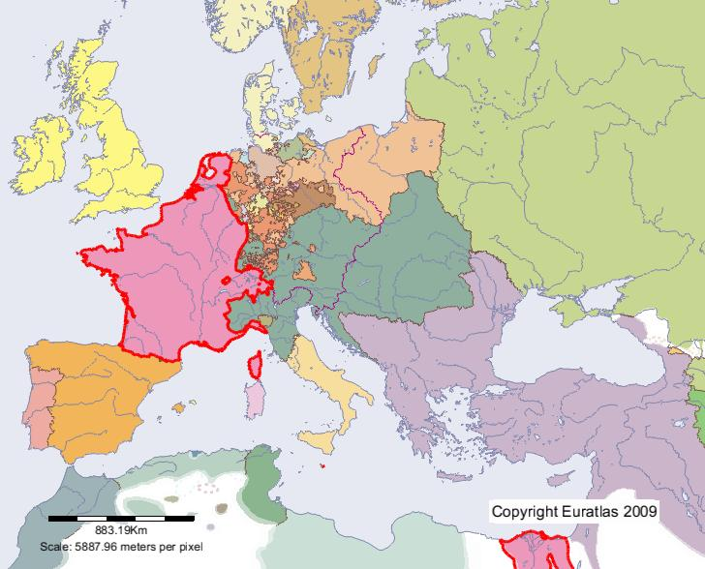

Netherlands – Nation Briefing

Despite setbacks and invasions during the 18th century, the Netherlands has emerged as one of the richest European states in the world because of their embrace of the cultivation system in its East Asian colonies. This renewed wealth has brought the nation back from the brink of bankruptcy caused by the Napoleonic invasions and wars in Java. This growth in turn has spurred industrialization in the nation, but the lack of indigenous natural resources makes expansion into Africa even more important. With a focus on the Bantu-speaking areas of Southern Africa, mining operations have already developed and the Berlin Conference is critical to defending these interests.

**Conference Goals:**

* Complete and total control over Southern Africa
* Removal of British control from Southern Africa
* Access to natural mining resources such as iron, copper, diamonds, and gold.

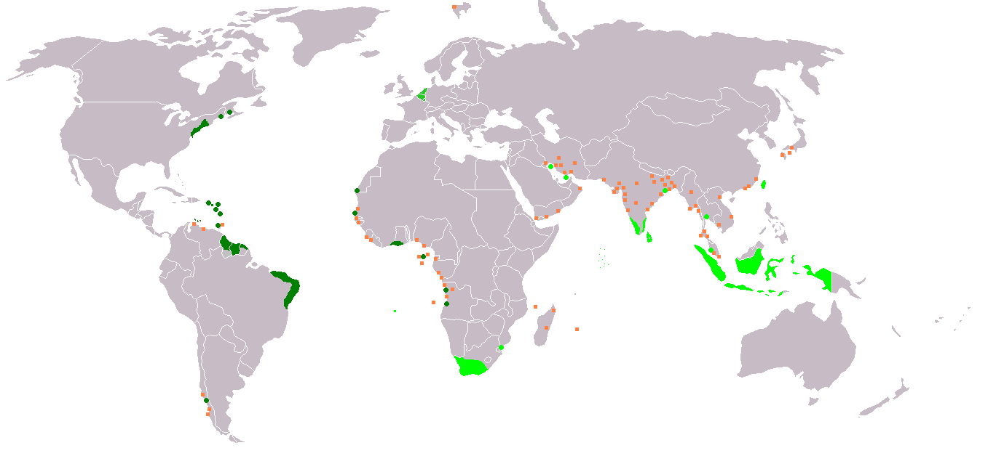

Portugal – Nation Briefing

Originally, one of the first great colonial powers, Portugal sent explorers across the world, claiming Brazil and establishing entrepôts across the world. Now though, a slow decline has overtaken the empire. Beginning with the invasion of Napoleon’s forces in 1807 and the declaration of independence of Brazil by Pedro I, Portugal now seeks to restore its colonial power and Africa can do just that for them. Seeking to expand colonial outposts in Africa to full nation-state status, the Berlin Conference will allow your nation to once again compete with other European powers.

**Conference Goals:**

* Expansion of colonial outposts bordering the Atlantic Ocean and Gulf of Guinea.
* Control of coastal areas near Madagascar
* Claim to natural resources such as coffee, diamonds, iron, copper, and magnesium.

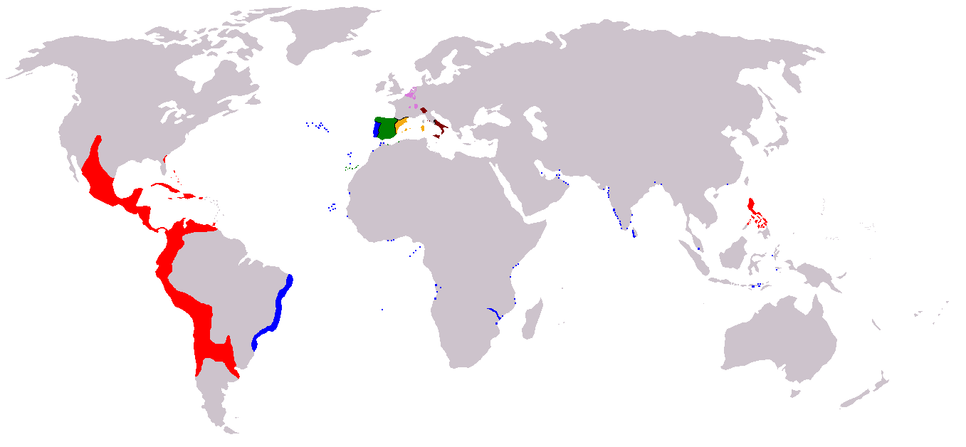

Great Britain – Nation Briefing

The reign of Queen Victoria has been glorious for the British people. After the loss of the American colonies to rebellion, your nation utilized their dominance of engineering and industry to facilitate the creation of an empire that is now unmatched. You are the most powerful of all the military and economic powers. Your empire now expands so far, that it is said that the sun never sets on the British Empire, and Africa is the last remaining you seek to control. The British already have a presence in Southern Africa where colonists have clashed with Dutch-born Africans known as Boers, but you want even more. Funded and supported by visionaries like Cecil Rhodes, the imperial ambitions of Great Britain and the British Empire can fully be realized.

**Conference Goals:**

* Claim all of Southern Africa to gain access to precious minerals like gold, bauxite, and diamonds.
* Claim the entire coastal area of western Africa to claim trade goods like peanuts, sisal twine, and rubber, as well as minerals like gold and magnesium.
* Connection of your northern colonies in Egypt to colonies along the Nile River.

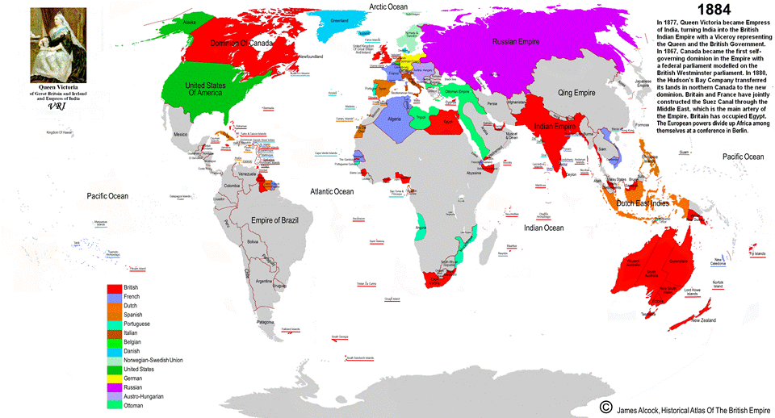

Delegate Proposal Map

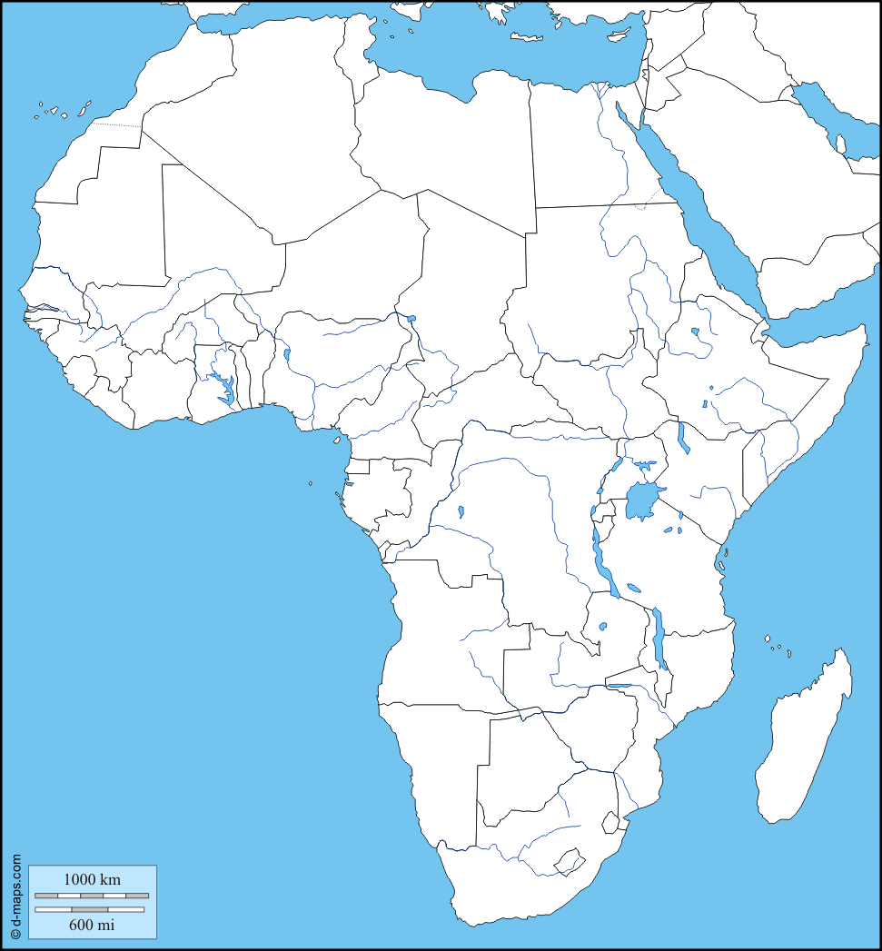

Berlin Conference Map



Climate Map

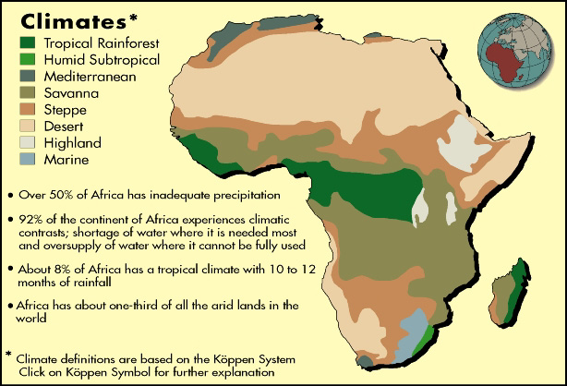

Resource Map

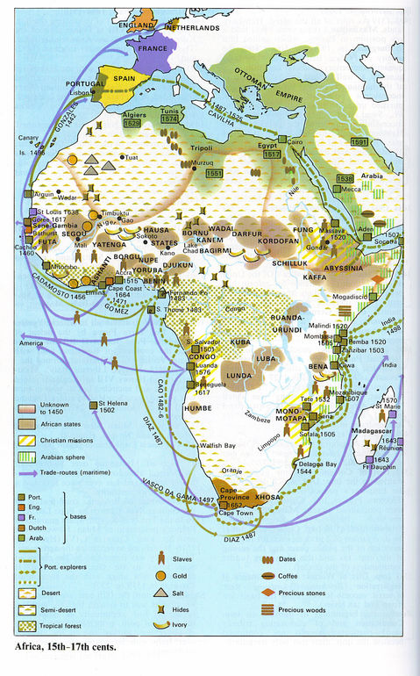

Language Map

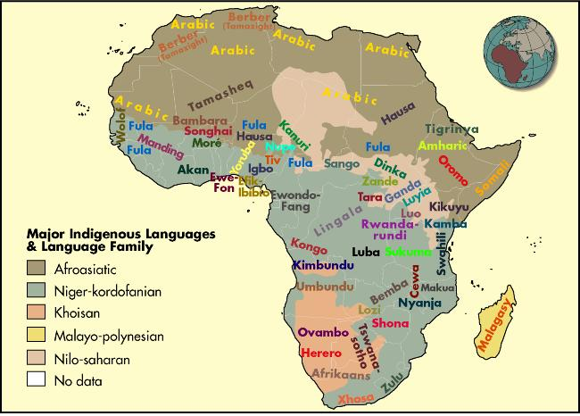

Religion Map

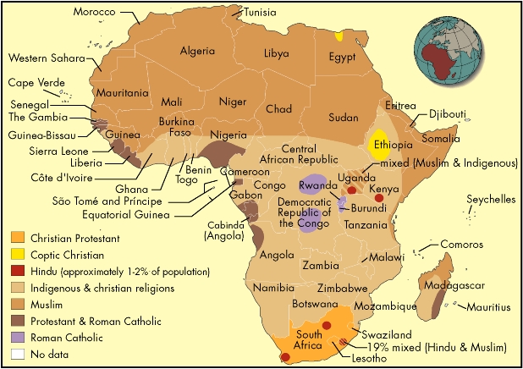

|  |  |
| --- | --- |
| Italian nationalists have supported their nation’s joining of the Triple Alliance and now they too demand a voice.  Create a nation for Italy along either the Red Sea or Horn of Africa | Abolitionists in the United States seek to repatriate freed slaves to their African homeland.  Create a free state in western Africa for these peoples |
| The Ottoman Empire has lost territory along the Nile River valley to British occupation and internal revolts.  Grant territory to the Ottomans unless the British and an ally can veto | Spain fears a loss of trade routes to other European powers, particularly in western Africa.  Create a series of small nation states in western Africa for Spain, including the area along the Strait of Gibraltar |
| Christian Ethiopians, one of the oldest sects in the world, are seeking their own nation to cement their link with Christian Europe.  Create a single nation in east Africa for these people | Germany, under the leadership of Bismarck demand recognition of their new industrial might.  Create two territories in central Africa with access to the ocean along the east and west coasts. Great Britain and an ally may veto |
| British colonies, backed by British naval power, have begun settling along the Niger River Delta.  Grant additional land to Great Britain along the west African coast. | Leopold II and the International African Association seek to create a nation to “civilize” these newly discovered lands.  Double the size of Belgium’s central Africa colony |
| Sweden, the third most populous country in Europe at the time, demands freedom of navigation along the Niger and Congo rivers  Redraw any existing boundaries to place the rivers entirely in their own nations | Dutch settlers refuse to recognize British control in southern Africa.  Create a new country so that they may remain independent |

Berlin Conference Map (1884-1885)

