**New Liberalism of the 1960 – 70s**

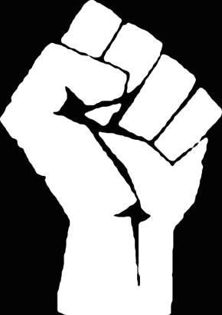*Overview:* During the 1960’s the Youth Counterculture sought to transform the social norms and break down long standing values that had limited social change. Feed by their exposure to new ways of thinking through the growth of prosperity and gaining college education the baby boomers took own what issues that had been long ignored by the United States.

**Assignment: New Liberalism of the 1960s**

Research your assign movement and develop a protest placard that explains factor that the assign movement wanted to change in the United States and what they achieved.

* **Prompt:** Between 1945 and 1975 various groups in the United States engaged in protest. Analyze the reasons protest emerged during this period.

**Requirements:**

* Title – Movements Name
* Slogan that represents the change your group seeks
* Image that represents the social change
* Explanation of causation: why is this protest movement developing in the United States during this time period
* Three fact statements: explanation of historic facts that demonstrate how this change came about
* Events: identify important events that supported your movements attempts to bring about change in the US

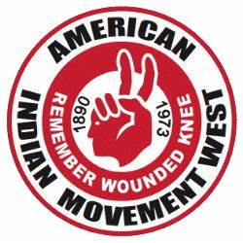**Research Movements:**

* Anti-War Movement: <http://www.english.illinois.edu/MAPS/Vietnam/antiwar.html>
* Black Power Movement: <https://www.thoughtco.com/what-is-black-power-4154338>
* Gay Liberation Movement: <https://www.infoplease.com/us/gender-sexuality/milestones-gay-rights-movement>
* Feminist Movement: <https://www.thoughtco.com/1960s-feminist-activities-3529000>
* Environmentalism: <https://photos.state.gov/libraries/mumbai/498320/fernandesma/June_2012_001.pdf>
* American Indian Movement: <https://www.thoughtco.com/american-indian-movement-profile-2834765>
* Chicano Movement: <https://www.thoughtco.com/chicano-movement-brown-and-proud-2834583>

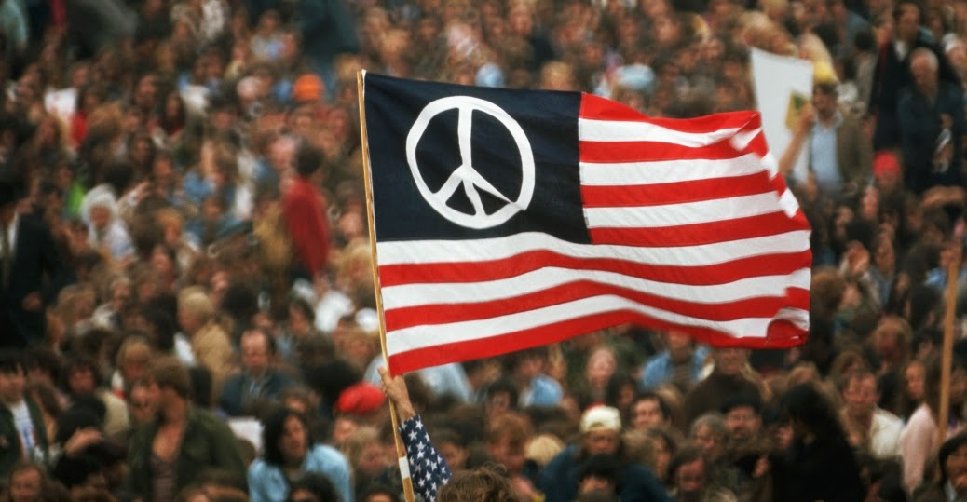

**“We are not the makers of history. We are made by history.”**

* [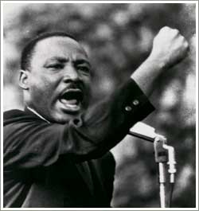](https://joemorton1401.files.wordpress.com/2013/02/martin_luther_king_jr24.jpg)**Martin Luther King Jr.**

|  |  |  |  |
| --- | --- | --- | --- |
| **Anti-War** | **Anti-War** | **Anti-War** | **Anti-War** |
| **AIM** | **AIM** | **AIM** | **AIM** |
| **Black Power** | **Black Power** | **Black Power** | **Black Power** |
| **Chicano** | **Chicano** | **Chicano** | **Chicano** |
| **Environmentalism** | **Environmentalism** | **Environmentalism** | **Environmentalism** |
| **Feminist** | **Feminist** | **Feminist** | **Feminist** |
| **Gay Liberation** | **Gay Liberation** | **Gay Liberation** | **Gay Liberation** |
| **Anti-War** | **Black Power** | **Feminists** | **AIM** |