1. **Key Points to Remember:**
2. As civilizations developed and grew, some emerged into large vast empires. A few examples would be
   1. ***Persians*** in the Middle East
   2. ***Romans*** in Italy
   3. ***Gupta*** in Northern India
   4. ***Chinese*** under its first emperor ***Shi Huangdi***
   5. ***Greeks***, will be united under ***Alexander the Great.***
   6. ***Ghanaian and Mali*** in West Africa – Ruler of Mali? _______________________________
3. These large empires were ruled by many different methods
   1. ***dividing the territory up into smaller provinces*** which were controlled by a governor
   2. ***Monarchy- ____________________________________________***
   3. ***Democracy- ___________________________________________***
   4. *Genghis Khan* was best known for these due to him having the largest in the world. All of the empires went through different leadership methods
4. ***Alexander the Great*** and his love of the Greek culture, he changed all of the hatred and spread the Greekculture throughout on the reigns he conquered, also known as the ***Hellenistic Culture***.
5. ***Silk Road*** under the rule of the ***Han Dynasty***.
   1. They traded greatly with the Romans showing the beginnings of Global trading.
6. The ***Roman Empire*** lasted the longest
   1. ***Republic*** *ruled by members of a Senate*
   2. Empire with ***Augustus Caesar*** as the emperor.
   3. *A time of peace* or ***Pax Romana***
   4. Divided into two empires and the Western Empire fell followed many years later by the Eastern side.
7. Development of many ***world religions*** that are still around today. Provide 3 examples for each.
   1. ***Polytheism***:
   2. ***Monotheism***
8. Know why the **Neolithic Revolution** is important
9. The Mongol Empire took over most of ASIA
10. The Zhou Dynasty came before the Qin Dynasty
11. Three examples of a primary source

i.

ii.

iii.

1. Ancient Egyptians used what to write on? ____________________
2. **Practice:**

1 How did geographic features influence the diffusion and settlement of both the Phoenician and Greek traders?

1. Both had access to the Mediterranean Sea.
2. The monsoon winds made ocean travel easier.
3. The arid climate encouraged migration.
4. Russia′s rivers provided ease of travel.

2. How did Pericles influence the functioning of Athenian government?

1. He introduced representative democracy
2. He expanded direct to new classes of free men
3. He increased the salaries of government officials
4. He greatly strengthened the authority of military leaders in society

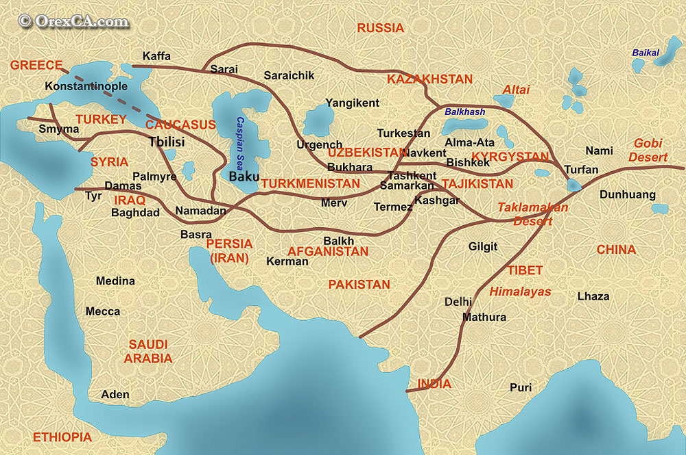

3. According to the map, how was the Silk Road associated with the development of cities?

1. increased trade along this route helped to establish cities within major empires
2. The development of many cities created a need for better roads
3. The Silk Road was built as an alternative to trade between large cities by the seas
4. European governments promoted free trade between major cities

4. Which ancient empire greatly influences American society today?

5. How does geography effect the development of culture?

6. Why do some elements of ancient history still exist in the modern age?

7. River Valley civilizations had to deal with ______________________ destroying their crops so they created __________________________________________ to channel the water and nourish their crops.

8. The Assyrian Empire was known for _______________________________________

9. Cyrus the Great was a __________ king, while Darius and Xerxes were ______________________ kings. These kings were all kings of the ______________________ Empire.

10. **Satrap-** ____________________________________________________________________________________

11. Difference between Confucianism, Legalism, and Daoism. ______________________________________________________________________________________________________________________________________________________________________________________________________________________________________________________________________________________________________

12. How many relationships in Confucianism? ___________

13. Founder of each philosophy of China:

1. __________________________________

2. __________________________________

3. __________________________________

14. Founder of Zoroastrianism ____________________________________________________