Use Text to Put these events in historical order with a date:

Decline and fall of the Aztecs

Crusades

Heian Japan

Seljuk Empire

Neo-Confucism evolved

Song Dynasty ends

Baghdad falls to Mongols

High Middle Ages start in Europe

Estates General meet for first time

Magna Carta

First Crusade

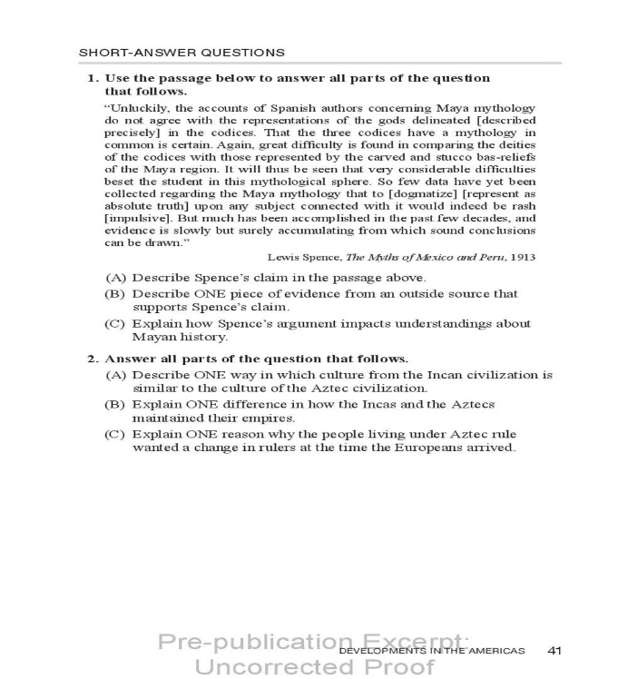

SAQ Tips

* Answer the question! If it is asking for political, give them GOV; social, give them class/gender friction
* Have at least one example of specific historical evidence. This is a FACT from the text/notes
* Aim for 3-5 sentences per part (A, B, C). So you will write 9-15 sentences for each SAQ. You have just ONE SAQ on this test

Put these social classes in order

China Feudal Europe

Artisan serf

Mean person artisan

Merchant knight

Scholar-Gentry lord

Noble Pope

Place these in the correct culture

Sufis

Foot binding

Sati

House of Wisdom

Grand Canal

Champa Rice

Chanampas

Mound building

Mita system

Griot

Renaissance

Three-field system

Al-Andalus

Rajput

Big Questions- brainstorm and write down anything that comes to mind that would fit this topic question

* Explain the effects of Chinese cultural traditions on East Asia over time
* Explain the effects of intellectual innovation in Dar al-Islam
* Explain the causes and consequences of political decentralization in Europe