NEWS FROM ACADEMICALLY GIFTED
The Middle School Edition
Quarter 2
Education is the most powerful weapon which you can use to change the world.
~ Nelson Mandela

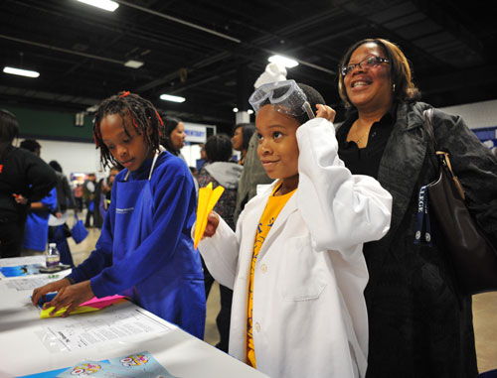  Plan now to attend the  2024 Choice Showcase!  GCS is a nationwide leader in magnet and choice schools, just one of the ways the district is personalizing learning. Families have a wide variety of choices for their children’s education—choices that build on or stimulate educational interests, foster academic achievement and provide cultural and ethnic diversity. As you begin to think about your child’s transition to high school, the AG Department would like to highlight the following programs that may be of interest to students who have been identified for academically and/or intellectually gifted services:  Advanced Academic Programming:  - Early College programs  - Early College at Guilford (Liberal Arts focus)  - Early College at NC A&T (STEM focus)  - Middle College programs  - International Baccalaureate Diploma Programs (4 locations)  - AP Capstone Program | Career Focused Opportunities:  - Academy of Computer and Information Science  - Academy of Advanced Manufacturing and Engineering  - Academy of Biomedical Technology and Specialized Health Science  - Academy of Transportation, Distribution, and Logistics  - Aviation Program  - Education and Advanced Sciences Program  - Health Sciences Program  - Performing Arts (Weaver or Penn Griffin) – School assignment based on address.  Choice programs are available to students who reside in Guilford County and transportation is provided to most program sites. Although all of our high schools offer programming that will meet the educational needs of your child, the choice programs focus on specific areas that may better align to your child’s interest and post-secondary aspirations. For more information on the choice options, visit Choice Schools and Programs website: https://www.gcsnc.com/Domain/2425  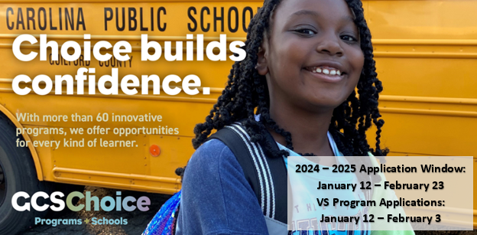
  News from our School:  - As the Choice Showcase gets nearer, it’s time to think about all of the options available to meet the needs of our Advanced Learners. Once the Magnet Window opens, take advantage of Open Houses and Tuesday Tours!  - Eighth Grade Families, BSMS will hold a virtual information session on January 9 about all things High School. The link will be provided as we get closer to the date.  - Don’t forget to join Guilford Gifted!  - DEPs were sent home mid-November for families to view. Only students with an attached highlighted letter need to return anything to Mrs. McCarthy.  - Feel free to contact Mrs. McCarthy if you have any questions or concerns regarding AG information.  - (336) 656-0432  - mccartl@gcsnc.com | From the GCS  AG Department  Guilford Gifted:  Guilford Gifted, formerly known as Guilford County PAGE, is a 501(c)(3) non-profit organization supporting our community’s brightest young minds with strong advocacy for the advancement of academically gifted education. Guilford Gifted provides the tools to engage and empower all those involved with academically gifted children, thereby building tomorrow’s leaders today. If you have not already done so, please visit their website to take advantage of their FREE membership opportunity.  Website: https://www.guilfordgifted.org/  Transition to High School:  Following the Winter Break, the AG Department in conjunction with the Guilford Parent Academy will host a meeting for rising 9th grade students to learn about their transition to high school. The meetings will be held virtually. More details will be shared once the dates have been confirmed. You may monitor the AG website for additional information.  Potential VS Eligibility:  The AG Department conducts a district review of data to identify students who have the potential for VS eligibility. In most cases, additional testing will be required in order to establish a student’s full eligibility for the VS Program. Before Winter Break, except for current VS and Brown Summit, TAG Chairs will send home notification letters to those who have been identified by the AG Department. Those receiving the notification will be able to apply to the program during the district’s choice application window (1/12/2024 – 2/3/2024). Once a student’s application is received, the AG Department will schedule the additional testing needed to establish eligibility. If your child did not receive an invitation to apply, you can request the AG Department to reconsider your child’s data, by using this link to submit your request: https://forms.office.com/r/G08xMTRxrr
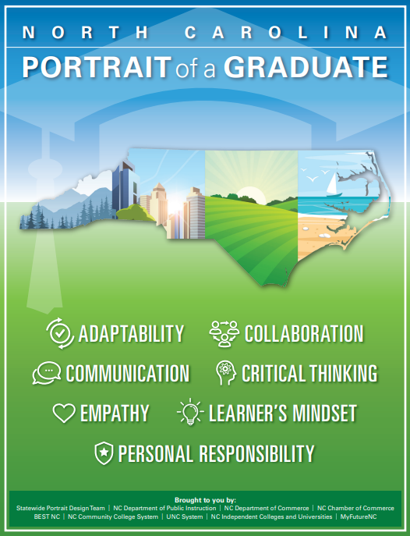
Using the North Carolina Portrait of a Graduate to Develop a “College Going” Culture in Your Home

The purpose of public education is to develop a productive workforce, create an informed citizenry, and provide for social mobility. To highlight this purpose, Guilford County Schools’ Board of Education has adopted the following mission statement, “Guilford County students will graduate as responsible citizens prepared to succeed in higher education, or in the career of their choice.” In alignment with the district’s mission, the Academically Gifted Department implements strategies that aim to maximize the achievement of academically and/or intellectually gifted students and those served in our talent development programming for these students to have a pathway to the college/university of their choice. To that end, in this quarter’s newsletter, we would like to highlight how focusing on the seven NC Portrait of a Graduate competencies can promote a “college going” culture in your home.

Rather it is one of the sixteen universities in the NC UNC system (e.g., NC A&T or UNCG); a private institution (e.g., Greensboro College, Guilford College, or High Point University); or a local community college (e.g., GTCC) – college admission counselors are seeking prospective students who demonstrate academic success as well an ability adapt, to collaborate, to communicate, to think critically, to show empathy, to learn, and to take personal responsibility. Many of the college application essays your child will write will focus on their experiences in which they have demonstrated one or more of the durable skills highlighted in the NC Portrait of a Graduate. Using the “I Can” statements provided by the North Carolina Department of Public Instruction (NCDPI), the chart below provides guidance to help families focus on these competencies in their homes.

Competency: | Focus Areas: | “I Can” Statement to Assist with Development at Home:
Adaptability | - Agility  - Responding to Feedback  - Inclusiveness | - I can use resources to respond to challenges and obstacles.  - I can use success criteria [rubric] to review and revise my work.  - I understand and respect the ideas, beliefs, and practices of others.
Collaboration | - Agreements  - Roles  - Cooperation  - Productivity & Accountability | - I can perform a variety of roles and responsibilities that help my team meet goals.  - I help to facilitate compromise by referring to our team’s agreements.  - I can complete my tasks on time consistently.
Communication | - Engaging in Conversations  - Giving & Receiving Feedback  - Presentation of Knowledge & Ideas | - I can respond to others’ questions and comments with relevant connections and ideas.  - I can ask for specific feedback on my work.  - I can deliver a focused, coherent presentation using factual, relevant evidence, sound reasoning, and well-chosen details.
Critical Thinking | - Information, Discovery, & Research  - Reasoning, Analysis, & Interpretation  - Solution Finding  - Justification | - I can conduct research and find multiple helpful and relevant sources to answer my questions about a topic.  - I can document my learning by organizing and prioritizing notes/data.  - I can analyze the effectiveness of my proposed solutions, explain what I learned, and determine need for further work on the problem.
Chart Continues on Next Page
Competency: | Focus Areas: | Student Behaviors to Develop at Home:
Critical Thinking (Continue) |  | - I can provide a clear, knowledgeable claim about the problem or issue.
Empathy | - Perception of Self & Others  - Relationships  - Diverse Perspectives  - Effective Listening | - I can understand the feelings, perspectives, and experiences of myself and others when interacting virtually or in person.  - I can create positive and supportive relationships with others.  - I can ask questions to help me better understand the viewpoints of others.  - I can ask questions that encourage the speaker to share more information.
Learner’s Mindset | - Curiosity  - Persistence  - Innovation  - Belief About Learning | - I can use resources to find ways to keep working when faced with challenges and obstacles.  - I can seek feedback from others to help me revise my ideas and products.
Personal Responsibility | - Task Initiation  - Planning/Prioritization  - Persistence  - Interpersonal Responsibility  - Intrapersonal Responsibility | - I can recognize when to stop a task and begin a new task with minimal prompting.  - I can create a detailed plan to complete a task and follow through.  - I can recognize when I need help and ask for it.  - I can remain on schedule and complete the outlined plan.
All information contained in the chart was taken directly from the NCDPI provided resources

The chart highlighted the grades 6 – 8 “I Can” statements that serve to remind parents/guardians of the skills that are needed to ensure that students develop the mindsets needed to thrive in the post-secondary plan of their choice. For students served by the Academically Gifted Department, our goal is that those post-secondary plans include college/university enrollment. At home, parents/guardians can use the “I Can” statements as a thermometer to check their child’s ability to adapt, to collaborate, to communicate, to think critically, to show empathy, to learn, and to take personal responsibility at home. In addition to the suggestions that you may have read in our elementary newsletter, here are some at home strategies you can use to help your middle school child continue to develop the Portrait of a Graduate competencies:
- Allow your child to be awaken by an alarm clock and begin their morning routine without prompting from an adult.
- Have your child use a paper or electronic calendar to organize school, home, and their extracurricular events.
- Some college interviews are held virtually. As such, use a free Zoom account to allow your child to have conversations with trusted adults to develop their virtual communication skills.
- Provide your child with an allowance and help them learn how to budget for expenses.
- Attend events, such as the NC Folk Festival, that allow your child to experience a variety of cultures.
- As your child begins to transition to high school, learn how they can become a part of organizations, such as the Greensboro Youth Council, that build collaboration and leadership skills.
- Allow your child to propose a family event and provide their evidence as to why the event meets a family need (e.g., give their rational for a family vacation).

Right now, it may be hard to imagine your child going to college. However, the road to college starts now and the NC Portrait of a Graduate competencies provide a framework for families to develop the non-academic skills that are also needed for post-secondary success.

Written by: Dr. Dee Jordan, AG Coordinator

