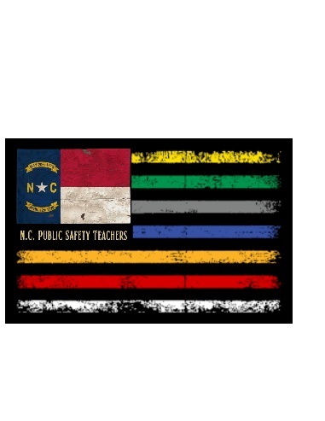
Honors Public Safety I
Education Syllabus
Chief Briton Wertz, BS, AAS
Firefighter/Paramedic
wertzb@gcsnc.com
SGHS #336-744-4250 ext. 666
Room B206-B

Course Description:

Public Safety I provides basic career information in public safety including Corrections, Emergency Medical Services, Firefighting, Emergency Management and Fire Management, Security and Protection, Law Enforcement and Legal Services. Federal Emergency Management Agency certifications are also a part of this course. Additionally, students will develop a personal plan for a career path in public safety. The course includes skills in each area, using resources from the curriculum and community, to help deliver instruction to the students.

Teaching-Learning Methods:

Teaching-learning methods in this course may include but are not limited to: a flipped classroom with students being assigned online lectures, readings, workbooks, presentations, discussions and critical thinking exercises. Evaluation procedures include quizzes, written examinations, peer collaborations, discussion posts, assignments, practical skills and lab performance. Projects, teamwork, leadership, and “followership,” also serve as instructional strategies to reinforce the curriculum content.
Certifications: American College of Surgeons - Stop the Bleed; FEMA - NIMS/ICS 100, 200, 700 & 800

Course Objectives:

At the completion of this course, you should be able to understand, describe and apply critical concepts and knowledge to:

- Common concepts in Law & Public Safety
- American Civic principles
- Court Systems
- Criminal Justice Systems
- Careers in Law Enforcement
- Careers in Firefighting/Fire Services
- Careers in Emergency Medical Services & Response
- Careers in Security & Protective Services
- Careers in 9-1-1 Telecommunications
- Careers in Emergency Management Services & Homeland Security
Attendance:
Student attendance is required and expected. School attendance policies will be adhered to and enforced. Repeated absences contribute to poor grades due to missed lectures and classroom experiences. It is the student's responsibility to get missed classroom lecture information and assignments not posted on Canvas upon returning from an absence.

Make-ups:
STUDENTS are responsible for scheduling and making up tests and assignments. Tests are to be made up the day of return following an absence unless other arrangements are made BY THE STUDENT with the Instructor. A maximum of 2 school days will be allowed for test make-ups (with PRIOR Instructor approval); otherwise, a "zero" will remain.

Other Student Materials:
Each student is to have a binder (as well as other mandatory supplies - see “Supply List”) that is to be devoted to Public Safety I only. Students are expected to come to class prepared - which means having ALL appropriate materials.
To pass this course successfully, a student must:
- Adhere to all procedures as outlined
- Follow the “Classroom Rules & Management Plan”
- Be present, prepared and on task
- Reflect good citizenship
- Keep phones, earbuds/headphones put away unless instructed
- Have ChromeBooks charged and with you each day

My expectations of you during this class will be the same as any employer would expect from you as their employee. All Guilford County Schools and Southern Guilford High School rules, chain of command structure, and all policies/expectations in the Guilford County Student Handbook, must always be adhered to. It is your responsibility to know what is in your student handbook as well as your Public Safety I class documents.

Semester Grades:
1st Quarter 40%
2nd Quarter 40%
Final Exam 20%

Classroom Grading Policy:
Homework/Classwork 25%
Quizzes 10%
Class Participation/Work Ethic/Citizenship/Professional Conduct 25%
Tests/Projects/Practicals 40%

A student is expected to devote his/her attention to the subjects being presented. Reading books, cell phone usage, or any other distracting activities will not be tolerated. Students in Public Safety I are preparing themselves for the professional field of public safety and students are expected to be mindful of their need to maintain professional standards at all times.
By signing the following page:
- You are signing that you have read information from Guilford County Schools and Southern Guilford High School about the program and fully understand the scope and intent of the program, the classroom rules, and the academic integrity required.
- You further understand that you will not hold the supervising school personnel, the school administration, or Southern Guilford High School/Guilford County Schools liable for any accidents and/or injury to either person or property incurred during participation in this program.
- You acknowledge reading and understanding this syllabus with your student.



Chief Briton Wertz
BS, AAS, Firefighter/Paramedic
Health Science, Public Safety & Emergency Medical Technology Education
Southern Guilford High School
wertzb@gcsnc.com

Student’s Name (PRINT LEGIBLY):____________________________________________Date:______________
Student’s Signature:_________________________________________________________________________
Parents’s Name (PRINT LEGIBLY):____________________________________________ Date:______________
Parent’s Signature:__________________________________________________________________________
Parent’s email (PRINT LEGIBLY):________________________________________________________________
I LOOK FORWARD TO WORKING WITH YOU THIS SEMESTER! GO STORM!
CLASSROOM /PRACTICAL PERFORMANCE
Expectations/Infraction Enforcement

Parents and Students are required to initial each Expectation category below. A copy of the initialed document signed by the instructor will be returned home to the parent for your file.

Posting on Social Media/Outside of Class Discussion/HIPAA violations regarding patient contact either in person contact or simulation. Parent/Student Initials ____/____

Any student that violates HIPAA or posts on social media regarding ANY patient contact simulated, in clinical, or in person will be failed from the course. Any student in the class who is aware of such a post and does not disclose the post will also be subject to failure of the course and ineligibility to sit for the NC OEMS state exam.

Student’s Signature:___________________________________________________Date:______________
Parents’s Signature:___________________________________________________ Date:______________
Instructor’s Signature:_________________________________________________Date:______________

