The Coming of WWII

Mussolini and Hitler signed an Axis Powers pact in 1939 with Tojo of Japan. On August 20, 1939 Hitler and Stalin of the Soviet Union, signed a 10 year non-aggression pact. Stalin was the leader of the communist party, Tojo was the leader of a Constitutional Monarchy, but without political parties. Hitler led the Nazi party of Germany, with a foundational belief in anti-Semitism, using Jews as a scapegoat for Germany’s problems during the depression. Japan was highly racist and believed that other races, especially in Asia (China, Korea) were inferior.

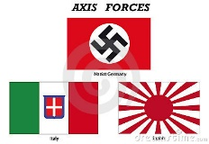Mussolini was the founder of Fascism. Strength of the State was a major idea, with him as “el Duce”, the Leader. War was a vehicle for these versions of extreme Nationalism.

In response to the Axis, France makes an alliance with Great Britain. LATER (1941) the USA and the Soviet Union join these allies. From 1935-1939 Hitler sent German armies into territories and demanded the outright ceding of others, all against the Treaty of Versailles. France & Britain did not enforce the Versailles Treaty because the horrors of WWI robbed them of the will to fight. Here is a list of the violations:

1935: re-armed with offensive weapons and moved troops into the Rhineland

1938: Annexed Austria; demanded the Sudetenland of Czechoslovakia (Munich Agreement)

1939: Annexed most of Czechoslovakia; Attacked Poland (finally Britain and France declare war)

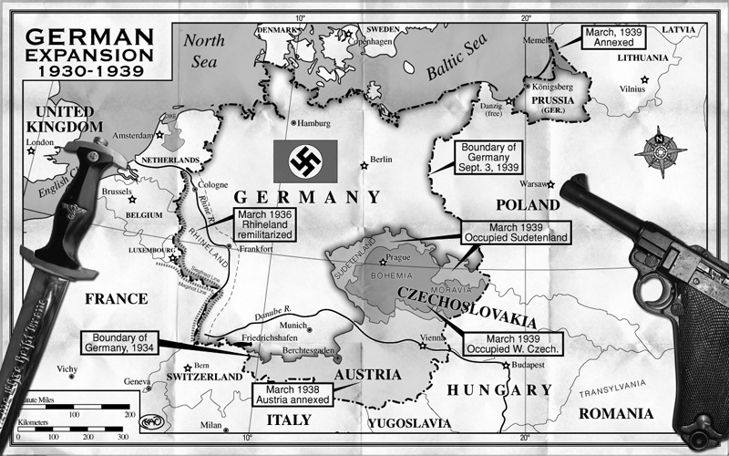

Appeasement: Trying desperately to avoid another catastrophic war just 20 years after WWI, the British leader, Neville Chamberlin hoped that by giving in to the demands of Hitler war could be avoided. The Munich Pact of September 30, 1938 gave Germany a portion of Czechoslovakia, the Sudetenland (some 3 million German-speaking people lived there). Hitler promised not to demand any more land. When Hitler took the rest of Czechoslovakia in the spring of 1939, Britain did not declare war. This “appeasement” only emboldened a dictator like Hitler, who saw appeasement as a weakness to be exploited.

France and Great Britain had a defensive alliance with Poland. On September 3, 2 days after the Germans “blitzkrieged” Poland, they both declared war. Italy and Japan remained neutral. The Soviet Union took the eastern 1/3 of Poland as part of the pact signed on August 20. World War II in Europe had started.