**Unit 8: The Cold War**

|  |
| --- |
| **Our Question:** Who was primarily responsible for the Cold War – the United States or the Soviet Union? |

**Part I:** Watch [THIS](https://www.youtube.com/watch?v=y9HjvHZfCUI) Crash Course World History video

**Part II:** Complete the primary source analysis below.

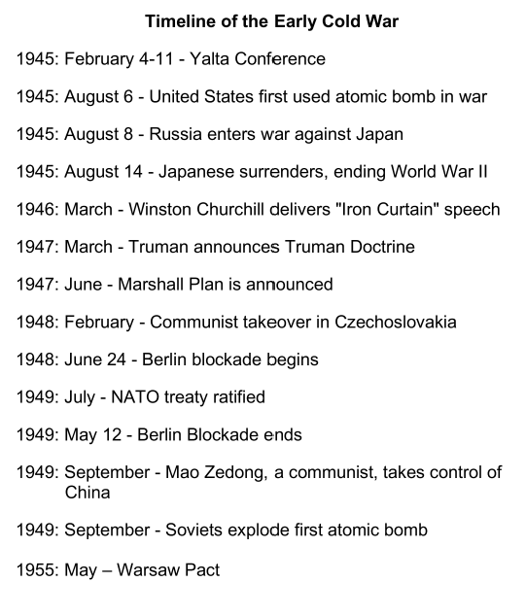

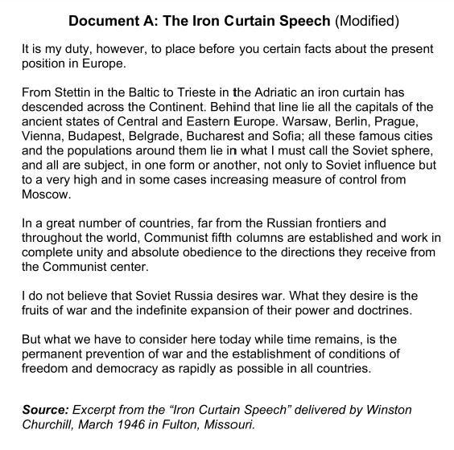

|  |  |
| --- | --- |
| **Document A: Iron Curtain Speech** | |
| 1. Sourcing: Who was Winston Churchill? Why would Americans trust what he has to say about the Soviet Union? |  |
| 2. Close reading: What does Churchill claim that the Soviet Union wanted? |  |

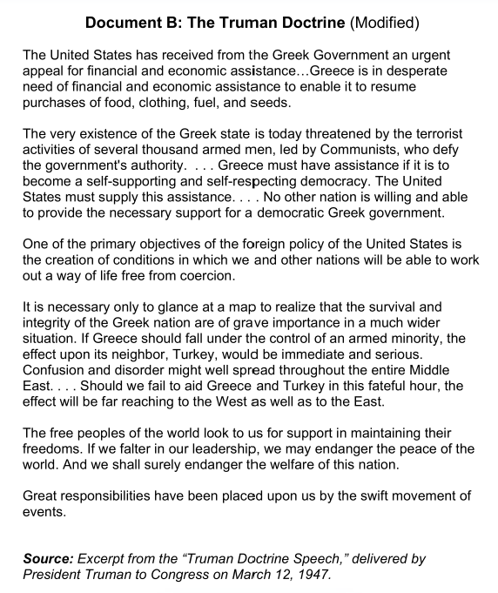

|  |  |
| --- | --- |
| **Document B: Truman Doctrine** | |
| 3.(Close reading: Why did Truman believe Greece needed American aid in 1947? |  |
| 4. Context: What does Truman mean when he claims, “Should we fail to aid Greece and Turkey in this fateful hour, the effect will be far reaching to the West as well as to the East”? |  |
| 5. Close reading: Does Truman present American policy as offensive or defensive? What words or phrases does Truman use to present policy this way? | Offensive or defensive?  Word used to present policy: |

|  |
| --- |
| **Hypothesis #1:** Record your first hypothesis: Who was primarily responsible for the Cold War - the United States or the Soviet Union? Cite evidence from the first two documents. |
|  |

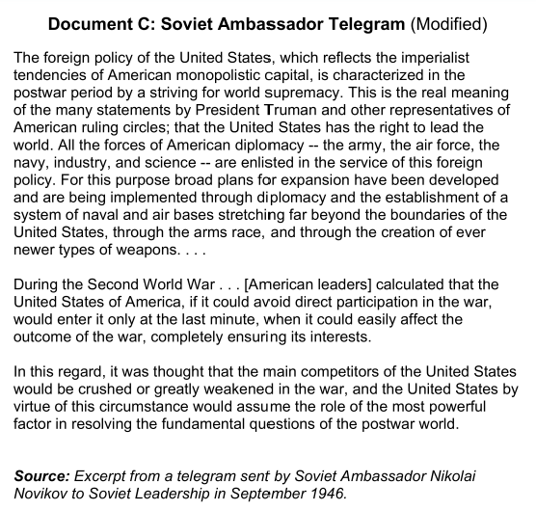

|  |  |
| --- | --- |
| **Document C: Soviet Ambassador Telegram** | |
| 6. Sourcing: Who was Nicholas Novikov? When did he write this telegram? | Who was he?  When was it written? |
| 7. Close reading: How does Novikov describe the United States? What evidence does he use to support his description? |  |
| 8. Context: What does Novikov claim the United States planned during the Second World War? |  |

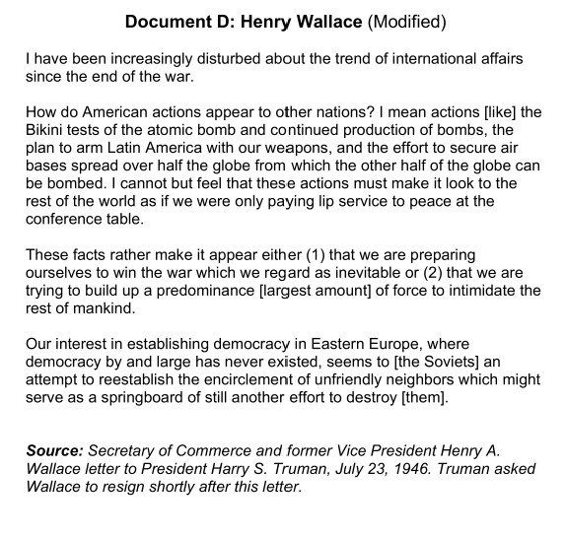

|  |  |
| --- | --- |
| **Document D: Henry Wallace Letter** | |
| 9. Sourcing: Who was Henry Wallace? When did he write this letter? | Who was he?  When was it written? |
| 10. Close Reading: What is Wallace’s main argument? |  |
| 11. Corroboration: How does Wallace’s description of American foreign policy compare to Truman’s and Novikov’s? |  |

|  |
| --- |
| **Hypothesis #2**: Record your second hypothesis: Who was primarily responsible for the Cold War - the United States or the Soviet Union? Cite specific evidence from the documents. |
|  |

|  |
| --- |
| Based on these documents and your knowledge of world history, what are some of the factors that caused the Cold War? |
|  |