**NEWS FROM THE ACADEMICALLY GIFTED DEPARTMENT**

**The Middle School Edition**

Quarter 1

When dealing with people, remember you are not dealing with creatures of logic, but with creatures of emotion. -***Dale Carnegie***

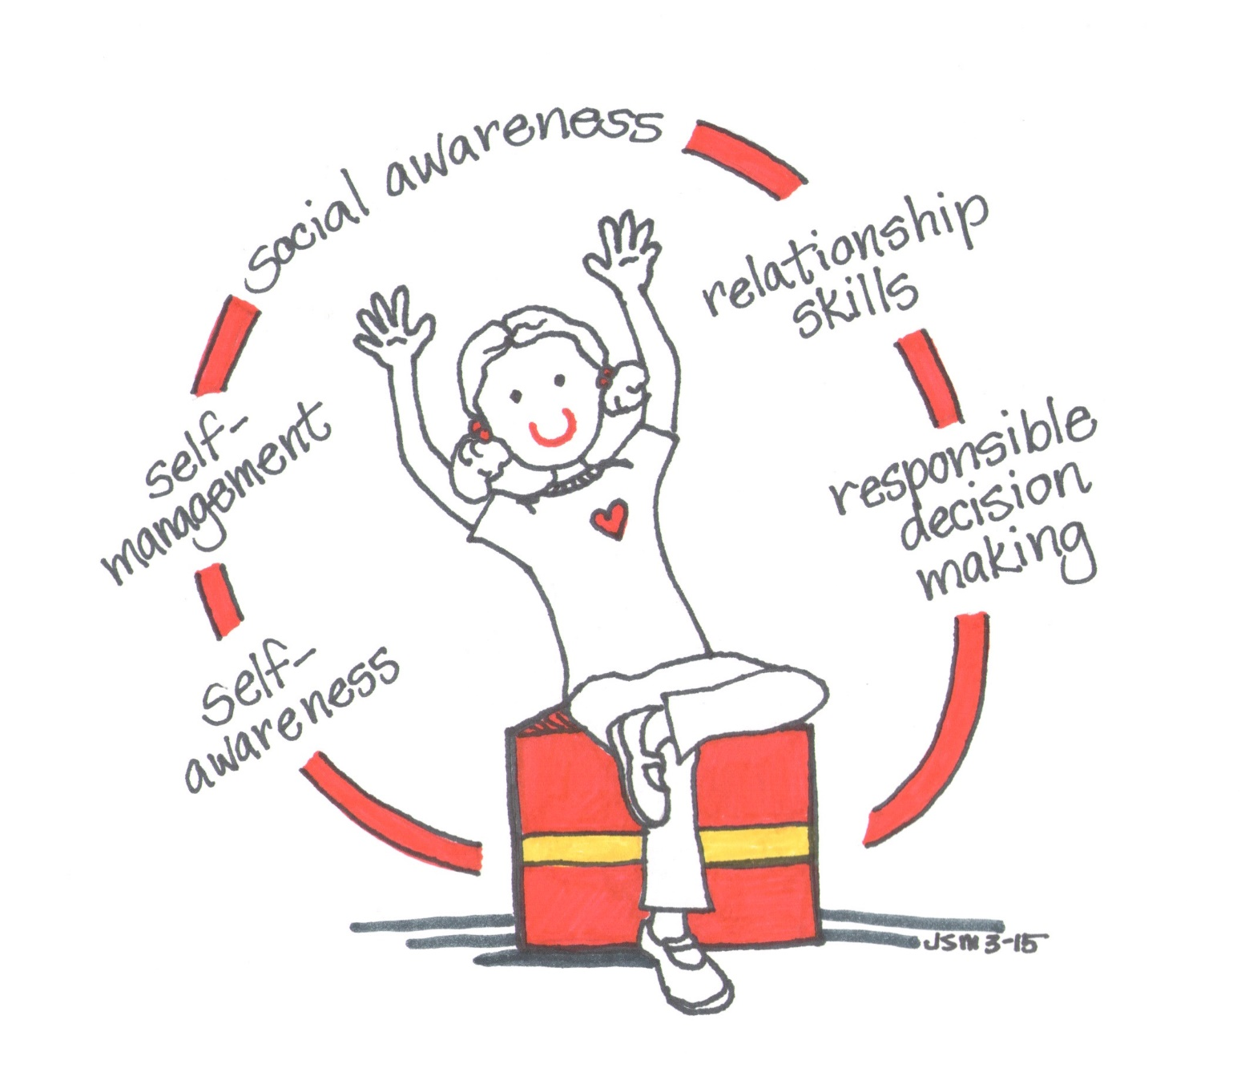

**Middle School AG Services**

At the middle grades level, to be identified as academically gifted, the student must have an achievement score at or above the 85th%ile in math and/or reading. Once identified, students in grades 6 – 8 receive the following services: **Enrollment in advanced coursework** (math and/or ELA based on identified area and district placement guidelines)

To ensure proper differentiation occurs in the classroom, teachers of academically gifted students should hold their AIG licensure or, at a minimum, have completed the district’s professional development on the characteristics of academically gifted students and proper classroom support for academically gifted and advanced learners. Annually, the school will provide a copy of the ***Differentiated Education Plan (DEP)***, which details how the curriculum provided in advanced coursework differs from grade-level content and supports the learning needs of academically gifted students. Each year, the school holds a beginning-of-year parent meeting for parents to review the ***DEP*** and seek clarification regarding their child’s AG service. In addition to the DEP, for newly identified students or for students who have added an identification area, the ***Student Eligibility Record (SER)*** is provided. The ***SER*** details the data that was reviewed for AG eligibility. The ***SER*** must be signed and returned by the parent/guardian.



**School Contact:**

**District Contact:**

Dr. Dee Jordan, AG Supervisor

(336) 370-8322; [jordand@gcsnc.com](mailto:jordand@gcsnc.com)

**News from Our School:**

**Welcome back Families!**

**Please feel free to contact Linsey McCarthy with any questions regarding AG.**

[**mccartl@gcsnc.com**](mailto:mccartl@gcsnc.com)

**(336) 656-0532**

***Parenting the Gifted Learner:***

***Home-School Communication***

2022 – 2023 Article Series:  Adapted from ***Parenting Gifted Children 101: An Introduction to Gifted Kids and Their Needs*** by Dr. Tracy Ford Inman and Dr. Jana Kirchner (2016)

Each quarter, the AG Department provides an article to share with our AG families that highlights the impact social and emotional needs have on students who display an intellectual and/or academic talent. For the 2022 – 2023 academic year, the book, ***Parenting Gifted Children 101: An Introduction to Gifted Kids and Their Needs,*** serves as our resource for the tips we are sharing with you to help you better understand your gifted learner. The unique needs and characteristics of gifted learners can create great successes as well as some moments of frustration. Communicating with your child and your child’s teachers is critical for helping your child be successful in scholastic endeavors. The four tips below are suggested to help you and your child have a successful school year:

1. **Be Informed:** This is more than being aware of school news and events. As the parent of a gifted learner, it is equally important for you to know your child. What are your child’s unique learning needs and strengths? What are your child’s dispositions that are key to how they interact with others? What are your child’s cognitive strengths and weaknesses? Knowing the answer to these questions will help you have the information to share with your child’s teachers as well as organize your home in such a way that your child can flourish.
2. **Prepare for Successful Parent-Teacher Interactions:** As stated above, the answers to the questions presented in the first tip can provide insight to you, as a parent, into the learning needs and strengths of your child. As such, when you notice that your child is having a specific issue at school, you can use what you have learned about your child to have a meeting with their teacher(s) to discuss specific needs and targeted solutions. Inman and Kirchner (2016) recommend that meetings between you and your child’s teacher(s) should not focus on things that are wrong but rather how you can work best with the school to support your child. The authors remind parents that solutions to any issues will require action not only from the school but from the home as well. They offer the following tips for parent-school communications:
   1. Begin with a positive statement that highlights something your child enjoys about the school/class.
   2. Share what strategies you use to bring out the best in your child at home.
   3. Share techniques you have used that did not work with your child at home and the reasons why.
   4. Establish your desire to create a partnership to ensure consistency with both home and school expectations.
   5. Understand that your child’s teacher is trying to create a learning environment that addresses the unique needs of all students in the class. When sharing solutions, consider the teacher’s ability to implement the strategy on a larger scale.
3. **Be an Advocate for Your Child and Gifted Education:** Seek ways to become actively involved in your child’s school. As the parent of a gifted learner, speak with the school’s chair of the Team for Academically Gifted (TAG) to ensure that the school-based team has a parent representative. Share information with your child’s teacher and other parents of academically gifted students regarding community resources that address the social, emotional, and academic needs of gifted learners. Finally, Inman and Kirchner (2016) recommend that parents of gifted learners join an advocacy group. In Guilford County, we are fortunate to have Guilford Gifted, which is an affiliate of the North Carolina Association for Gifted and Talented (NCAGT). Guilford Gifted was formerly known as Guilford Partners for Advancement of Gifted Education (PAGE). As a 501(c)(3) non-profit organization, Guilford Gifted provides the tools needed to engage and empower all families with children who demonstrate a talent in intellect and/or academics. The Executive Board of Guilford Gifted works closely with the staff of the district’s AG Department to address community concerns regarding academically gifted education in the Guilford County Schools System. Parents seeking to become more involved with gifted education in Guilford County are encouraged to join this organization. For the 2022 – 2023 school year, membership in the organization is FREE!