Grimsley High School

Ben Barnard/Room 204

[barnarr@gcsnc.com](mailto:barnarr@gcsnc.com)

Tutorial: during lunch and after school by appointment

**Course Description**

Theory of Knowledge (TOK) is the central course in the International Baccalaureate Diploma programme.  In other courses you will examine literature, science, mathematics, social studies, *et al*, but ToK invites the diploma seeker to examine the common bonds between these courses.  The obvious thing is that all other courses at Grimsley are designed to enlarge your knowledge in that subject area.  In TOK we will examine the foundation of **knowledge** itself and discover that different areas of study have different standards of knowledge.

In this course we will examine ***not*** ***what*** we know but ***how*** we know. We will do this by examining personal and shared knowledge; ways of knowing; and areas of knowledge. IB Theory of Knowledge is the only exclusive course in the IB Diploma Programme: a student must be a diploma candidate to enroll in this class. Two other critical elements will be address through TOK:  CAS (Creativity, Activity, and Service) and the Extended Essay (EE).  IB Diploma candidates are required to develop, participate and record their experiences in participating in Creativity, Activity, and Service.  The Extended Essay diploma requirement entails developing a topic, conducting appropriate and ethical research and then writing a 4000-word research paper in a subject area and topic of the student’s choosing.  Grimsley’s amazing Media Center specialist will be instrumental in the development of this research paper.

**Expectations**

AP and IB classes are college level classes in a high school setting; they should not be mistaken for high school level classes.  Students choosing to take AP/IB classes are looking for a challenge that they are not necessarily getting from Honors level courses.  The expectations are higher and the work load is greater.  Additionally, students are expected to complete all components of assessment for AP and IB evaluation, including IB Internal and External Assessments, IB exams, and AP exams.  Students who do not meet this requirement will have to pay a portion of the examination fee: $15 for AP exams and $45 for IB exams.  Please note that oversleeping, forgetting about an exam, getting in traffic delays, and feeling ill without a doctor’s note are not accepted reasons for missing an exam or taking a late exam.

A student can expect their homework to take an average of 30 minutes to 1 hour, per class, to complete. Some classes have the regular homework of studying the material discussed in class and the time required for such homework will depend on the student.  Generally, AP and IB students should expect more: more learning, more work, more writing, more challenges, and more from themselves.

**IB Assessment**

Theory of Knowledge is a required element of the IB Diploma Programme.  Two products will evolve directly from the TOK course which will be assessed by the IB.  These products will be spread out over the course to two years:

Junior Year: 10-minute presentation (up to 30 minutes if there are three group members) on a knowledge question and a real-life situation of students’ own choosing.

Senior Year: 1600-word maximum essay in response to one of six prescribed essay titles published by the IB. **During the senior year, students will meet every other week during lunch to complete TOK requirements.**

The grades of both of the TOK elements (40% for Orals and 60%for Prescribed Titles) will be combined by the IB and students will be assigned a grade by the IB of A, B, C, D or E.  Likewise, a mark will be awarded for each student’s Extended Essay (A-E).  These two grades will then be used to assign bonus points toward the award of the IB Diploma:

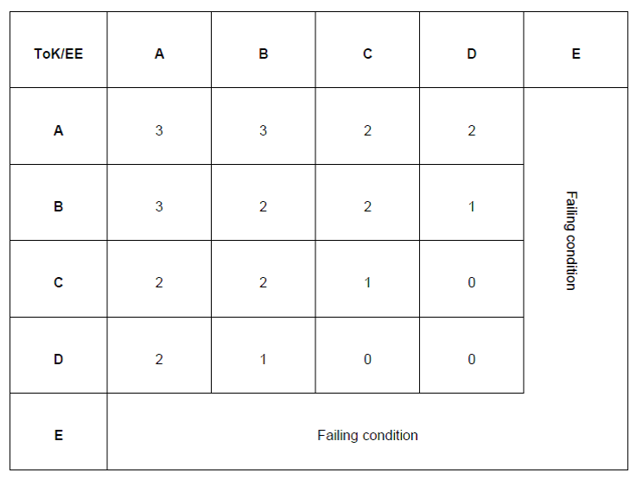

**Grading Policy**

Assessment will be in the form of essays and reflective writing, presentations, quizzes, seminars, Extended Essay assignments, and CAS completion. Essays and presentations will be graded based on IB’s assessment rubrics:

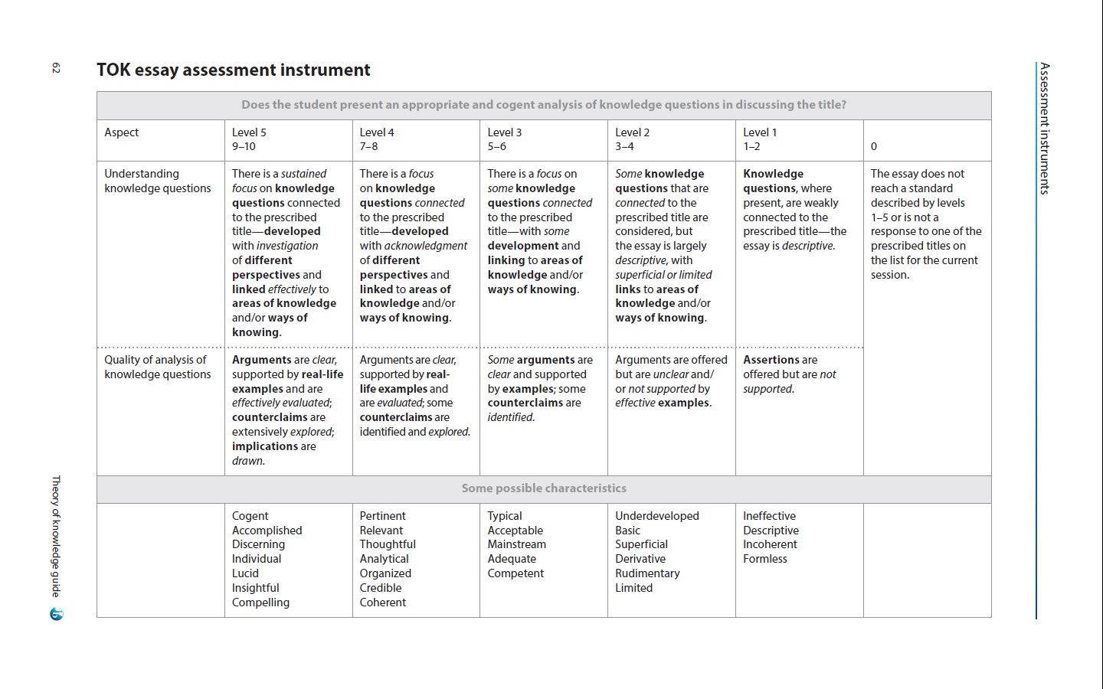

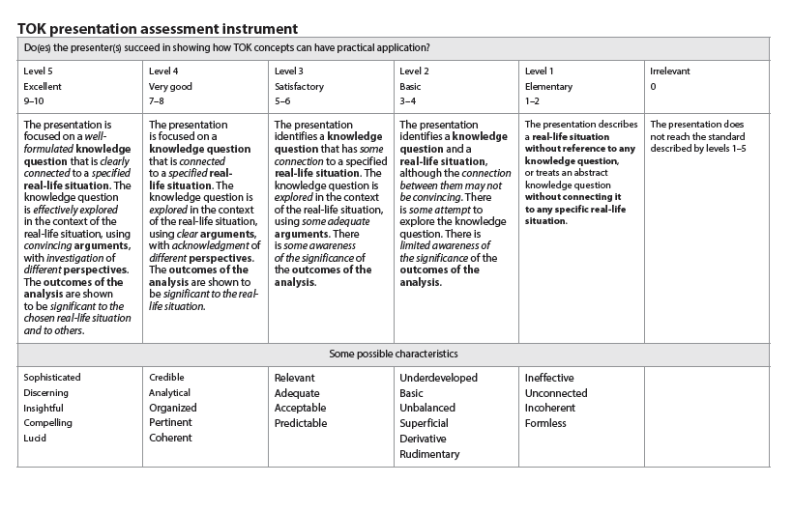

The IB assessment rubrics will align with the following grades at Grimsley High School:

|  |  |
| --- | --- |
| **Essay 1st Semester:**  9-10: 100  7-8: 90  5-6: 80  3-4: 70  2: 60  1: 55  0: 0 | **Essay 2nd Semester and Presentation Year-Round:**  10: 100  9: 95  8: 90  7: 85  6: 80  5: 75  4: 70  3: 65  2: 60  1: 55  0: 0 |

Classroom grades:

|  |  |  |  |  |  |  |  |  |  |  |  |
| --- | --- | --- | --- | --- | --- | --- | --- | --- | --- | --- | --- |
| **Breakdown of Classroom Grades**  Essays/Tests (essays, presentations, etc.): 25%  Quizzes/Seminars: 25%  Journals/Daily Work: 25%  CAS/EE: 25% | Grading Scale   |  |  | | --- | --- | | **A** | 90 - 100 | | **B** | 80 – 89 | | **C** | 70 – 79 | | **D** | 60- 69 | | **F** | 50 or Below | |

**Unit Schedule (Units will last approximately two weeks)**

|  |  |
| --- | --- |
| **Semester 1:**  Unit 1: Think TOK  Unit 2: Know Thyself; Know Others (Personal Knowledge and Shared Knowledge)  Unit 3: Way of Knowing (Sense Perception)  Unit 4: Way of Knowing (Language)  Unit 5: Way of Knowing (Emotion)  Unit 6: Way of Knowing (Reason)  Unit 7: Presentations on Other Ways of Knowing and Areas of Knowledge (Memory, Imagination, Faith, Intuition, Indigenous Knowledge Systems, Religious Knowledge Systems)  Unit 8: Area of Knowledge (Ethics) | **Semester 2:**  Unit 9: Area of Knowledge (Math)  Unit 10: Area of Knowledge (Natural Sciences)  Unit 11: Area of Knowledge (Human Sciences)  Unit 12: Area of Knowledge (History)  Unit 13: Areas of Knowledge (Arts)  Unit 14: ToK Final Presentations  Unit 15: Extended Essay Bootcamp |

**Class Rules and Procedures**

**Materials Needed**

Three-ring binder (may be shared with other classes if organized)

Blue or black pens and #2 Pencils

**Leaving the Classroom**

Students are expected to make use of the time between classes to use the bathroom. Students will not be allowed to go to the bathroom while I am teaching or students are presenting. When we are doing an activity, if a student must go to the bathroom, he/she will take a hall pass. He/she must also sign out on the wall next to the door. Only one student at a time will be allowed to go to the bathroom.

**Tardy Policy (per the Grimsley High School Handbook)**

A student is considered tardy to class if he/she is not in his/her assigned location when the tardy bell rings. If a student is late to school and has a written excuse from a parent, the student must first come to the attendance office to get a pass to class. If a student arrives late to school without a note but it is within ten minutes after the final bell rings, the student should report directly to class. If the student arrives to school ten minutes after the final bell rings without a note, they must report to the attendance office.

1st tardy – teacher warning and parent contact

2nd tardy – teacher-given consequence and parent contact

3rd tardy – teacher-given consequence and parent contact

4th and beyond – administrative referral and parent contact

*The tardy count restarts each quarter.

**Students arriving to class more than ten minutes late without an excused note will be considered skipping and subject to disciplinary action.

**Electronics Policy**

All electronics, including cell phones and laptops, have a potential for pedagogical use, but should be used appropriately. Any use of electronics outside the exigencies of the classroom will result in disciplinary action.

**Late Work/Homework Policy**

It is very important to be present every day for class, but if you must miss a day of class, you are responsible for making up work. File folders will be hanging up containing missing assignments. If you have any questions about missing work, see me before or after class. You will have three days after your absence to complete make-up work.

Most homework in TOK will consist of preparing for presentations, finishing an assignment started in class, reading course materials, typing an essay, or completing other IB Core requirements (CAS and Extended Essay). If work is submitted late, the following will occur:

Late Policy

First day late = 15 points off

Second day late= 10 more points off

Third day and subsequent days late= 10 more points off

After 10 days, the assignment in question will receive a score of zero.

**Academic Honesty**

IB takes academic dishonesty very seriously. Grimsley High School does as well. The following all constitute academic dishonesty, as defined by IB:

a. Plagiarism- not fully and completely acknowledging when using words or ideas of another person

b. Collusion- any form of assistance from others, including copying the work of peers or inappropriate use of

websites for assistance

c. Duplication of work- the original work of the student, and cannot be a duplicate of previous work within the IB

Diploma Programme.

d. Any other behavior that gains an unfair advantage for a candidate or that affects the results of another candidate

If a teacher discovers evidence of student malpractice, they will first discuss the issue with the student.  If evidence of malpractice is found, the following will occur:

First Offense:

1) The parent will be contacted, and a formal administrative write-up will occur.  This write-up will serve as warning and will remain on file as documentation if any other instances of malpractice occur.

2) The teacher, parent, and student will discuss the seriousness of malpractice and the resulting effect on the class grade.  If the student is an IB student (either in Grimsley’s Diploma Programme or as a Grimsley Pre-IB student), the IB Coordinator will be notified and the malpractice will be placed in the student’s file.

3) The student earns a 0 class grade for the assignment.

Second Offense:

1) The parent will be contacted, and a formal administrative write-up will occur.  This write-up will result in disciplinary action.

2) The teacher will notify the IB Coordinator, if applicable. The IB Coordinator will contact the student and his/her parents and decide if the student will be allowed to continue in the IB Diploma Programme at Grimsley High School.

**Class Rules:**

1. Respect everyone in the class—the teacher, fellow students, and yourself.

2. Come to class prepared—physically, behaviorally, and mentally.

3. Take care of the classroom and all classroom materials. (Clean up after yourself.)

4. Put away ANYTHING that does not pertain to TOK (work for other classes, cell phones, etc.)

5. Participate! Participate! Participate! ☺