**Hairston Middle School**

Semester

|  |  |  |  |
| --- | --- | --- | --- |
| **Teacher Name** | **Email Address** | **Phone Number** | **Office Hours** |
| **Ms. J. Williams** | [**Williaj12@gcsnc.com**](mailto:Williaj12@gcsnc.com) | **336-378-8250 ext. 1652** | **9:00 – 4:00** |
|  |  |  |  |
|  |  |  |  |
|  |  |  |  |

Sign up for my Remind 101 by ….

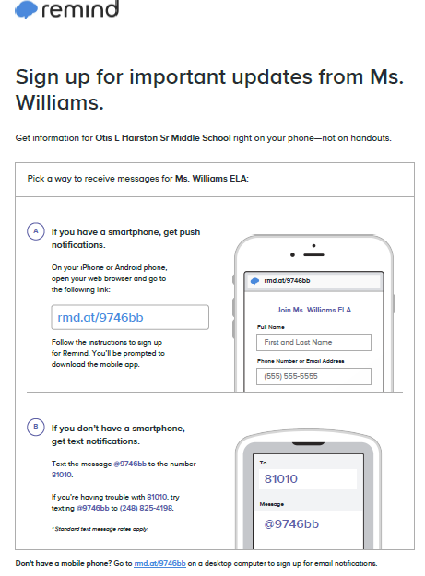

|  |
| --- |
| **Introduction** |

Welcome to an exciting new school year at Otis L. Hairston Middle School. My name is Ms.J. Williams. I will be your 6th grade ELA. I am a graduate of University of North Carolina and North Carolina A$T State University. I have taught ELA for 3 years. The best part of teaching is watching that lightbulb go off when a students understands an assignment!

This ELA class is designed to increase your reading comprehension skills and analytical skills through reading, writing, speaking, and the study of the literature. This year you can expect to engage with your teacher and the class through a variety of online platforms. Instructions will be posted in Canvas so make sure you read the expectations of each assignment carefully. Because we are a community of learners, please also expect to work periodically in group situations and to present information to your peers in groups or individually.

To gain access to my Canvas page, go to ….

|  |
| --- |
| **Standards and Units of Study** |

Mathematics Grade 6 will focus on five clusters of mathematics, as outlined in North Carolina 6th Grade Mathematics Standard Course of Study (to view North Carolina 6th Grade Mathematic Standards [CLICK HERE](https://files.nc.gov/dpi/documents/curriculum/mathematics/scos/current/6-8.pdf)). This will include Ratio and Proportional Relationship, The Number System, Expressions and Equations, Geometry, and Statistics and Probability, which are basic foundational clusters that prepare students for higher level mathematical courses. This course will show relevance to student learning and understanding of mathematics when applied in the real world.

Units of focus:

1. Main Idea 2. Citing Textual Evidence 3. How a story’s plot unfolds
2. Theme 5. Author’s Perspective 6. Figurative Language
3. Compare & Contrast different text 8. Context Clues 9. Greek & Latin root words

|  |
| --- |
| **Materials** |

* Notebook
* Pens/pencil

|  |
| --- |
| **Assignments** |

All assignments will be listed in Canvas. To access the assignments, click on the month, then week. Here you will see a suggested schedule for completing lessons and assignments. The schedule will also include the due date for each assignment. All assignments should be submitted in Canvas by 11:59 p.m. on the due date.

|  |
| --- |
| **Live Sessions** |

Dates and times of live sessions will be included in the weekly schedule. During this time, we will teach lessons, answer student questions, work in small group, or students will complete assessments. Attendance is required, and students will adhere to the School’s code of conduct. Students are expected to be civil and respectful. The student will use the hand-raise button when he/she wishes to speak, students will post respectful comments in the chat box.

|  |
| --- |
| **Grading Policy** |

1. **Tests:** (35%)

Tests are generally scheduled at the end of each chapter/unit and two common assessments during the unit. Students will only be allowed to take a test during live sessions. Failure to complete a test will result in a grade of zero for that test.

2. **Quizzes:** (25%)

Quizzes will generally be given at least once a week. These assessments consist of no more than 8 problems and can be made up if your first grade is a D or lower. Quizzes must be taken on the day they are assigned.

3. **Practice**: (30%)

Practice will generally be assigned in each lesson. It is very important you attempt to answer all of the questions to the best of your ability and refer to the notes, text, or video provided during the lesson for help. Immediate feedback (24-48 hours) will be given for all practice assignment; therefore, students will have an opportunity to improve practice assignment grades throughout the week.

4. **Team Project:** (10%)

Each term, students will have one project that involves them applying one or multiple skills learned in class to the real world. Each project will be accompanied with a rubric outlining the expectation. Students will work as a team to complete the project and the projects will be posted on the School’s Website for public viewing.

**Grading Scale**

A – 90% - 100%

B – 80% - 89%

C – 70% - 79%

D – 60% - 69%

F – 59% and below

|  |
| --- |
| **Absences/Make-Up Work** |

It is very important that you log into Canvas **on time everyday** and participate in class in order to pass. Please ask the teacher about any assignments missed if you must be absent. **You** are responsible for the work you miss. Making up assignments is at the teacher’s discretion. **No extra credit will be given.**

|  |
| --- |
| **Inclusive Learning Environment Statement** |

The best learning environment––whether in-person or virtual instruction, is one in which all members feel respected while being productively challenged. At Hairston Middle School, we are dedicated to fostering an inclusive atmosphere, in which all participants can contribute, explore, and challenge their own ideas as well as those of others. Every participant has an active responsibility to foster a climate of intellectual stimulation, openness, and respect for diverse perspectives, questions, personal backgrounds, abilities, and experiences, although instructors bear primary responsibility for its maintenance.

A range of resources is available to those who perceive a learning environment as lacking inclusivity, as defined in the preceding paragraph. If possible, we encourage students to speak directly with their teacher about any suggestions or concerns they have regarding a particular instructional space or situation. Alternatively, students may bring concerns to another trusted adult (such as an counselor, social worker, teacher, or administrator).

|  |
| --- |
| **Academic Honest Policy** |

[International Baccalaureate Academic Honesty Policy Handbook](https://1.cdn.edl.io/kKW5FJodEbgJem5Oa3nitIbGRUHC3QXFt5jU11BUAt6DXQVT.pdf)

Hairston Middle School recognizes and follows the academic honesty policy set forth by the IBO for the Middle Years Program.  Plagiarism is recognized worldwide as a serious academic offense.  Ignorance of the working definition of plagiarism is not a valid excuse for lapses and does not prevent penalty from being applied to work submitted as original.  With that being said, Hairston Middle School teachers and staff will continually work with students to provide them with definitions of academic malpractice and plagiarism, but also outline strategies to prevent it.  Our goals throughout a student's educational experience at HMS concerning academic honesty are to teach the IBO definitions of plagiarism, collusion, and malpractice, and help make aware the expectations of behavior that is responsible and ethical.

Some highlights from the IB Academic Honesty Policy above include:

* Candidates are required to act in a responsible and ethical manner throughout their participation in the Diploma Program and examinations.
* Candidates must avoid malpractice, which is defined by the IBO as any behavior that results in, or may result in, the candidate or any other candidate gaining an unfair advantage in one or more assessment components, including:
  + **Plagiarism**, which is the representation of the ideas or work of another person as the candidate's own.
  + **Collusion**, which is knowingly supporting the malpractice activities of another candidate, as in allowing one's work to be copied or submitted for assessment by another
  + **Duplication of work**, which is the presentation of the same work for different assessment components and/or Diploma Program requirements
  + **Other misconduct during an IB examination session**, including taking unauthorized material into an examination, participating in behavior that disrupts or distracts other candidates, or communicating with another candidate.

If a case of malpractice has been established, no grade will be awarded in the subject(s) concerned and the student must complete the assignment under the supervision of an authorized adult.

***Disclaimer***

*The teacher reserves the right to make modifications to this information throughout the school year.*