Japan: The Meji Era 1867-1912

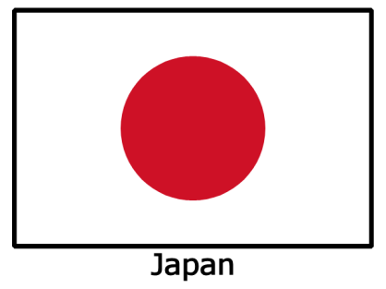

Tokugawa Shogunate (1603-1868)

* Isolationism: Japan cut itself off from _______________   
  (1635)
* Feudalism: __________ (military leader) and _________ (lord) held power

The U.S. “Opens” Japan (1853)

* Who comes first? Commodore Matthew Perry and _____________ ships
* Why?:
  + Ensure good treatment of shipwrecked ___________
  + ___________
  + a place to re-supply and repair ___________
* In 1862, the Japanese emperor sent officials and scholars to study the situation in China. They learned Japan must adapt or be _____________.
* Treaty of ______________: Japanese agree to open two ports to ________ to U.S. in 1854
  + Eventually Great Britain, Russia, and France gain similar trading rights

Meiji Restoration (1868-1912)

* Why is it called the “Meiji Restoration”?: the _____________ was restored to power
* What does “Meiji” mean?: _________________ Rule

Reforms of the Meiji Restoration

* 1. _______________ ended: shogun and daimyo lost power
* 2. Adopted western ways: ________________, modern ____________
* 3. _____________: Japanese studied ideas from the U.S., Britain, France, etc

“Took the Best from the ___________”

* Industrialization: ____________
* School system: ________
* Army: ___________

Japanese Imperialism (early to mid-1900’s)

* Why did Japan become imperialistic?: needed ____________ for their factories (did not have their own)
* Who does this remind us of? __________________
* Japanese imperialism leads to two wars:
* 1. Sino-Japanese War (1895) China vs Japan: ________ won, gained Korea and Taiwan
* 2. Russo-Japanese War (1904-1905) Russia vs Japan: _______ won, gained Manchuria
  + Why does Japan win these wars?

