The purpose of this document is to assist students in selecting Encore requests for 6th grade in their PowerSchool student portal.

1. Students should Login to **NCEdCloud > Access PowerSchool Student** **2**. Click the **pencil icon** to the right of the course

Choose **Class Registration** subject (see directions below). If you Choose Band or

The list of course subjects available will appear on the screen. Orchestra then select 1 A/B day Encore. All other students should choose 3 A/B day Encores.

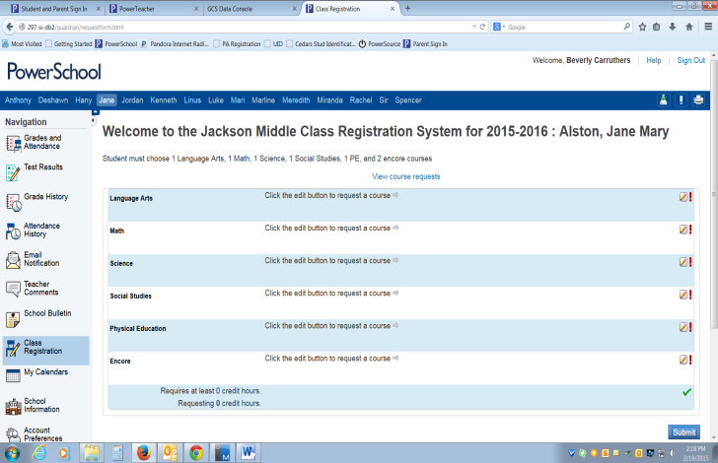

All students should choose 1 alternate A/B day Encore that is different than their other encore choices.

Then Click **OK**.

***Elementary Counselors will assist any students who***

***are unable to register from home after the***

***registration window has closed.***

1. **Click Class Registration (left)**
2. **Click the pencil Icon to edit/choose course (right)**

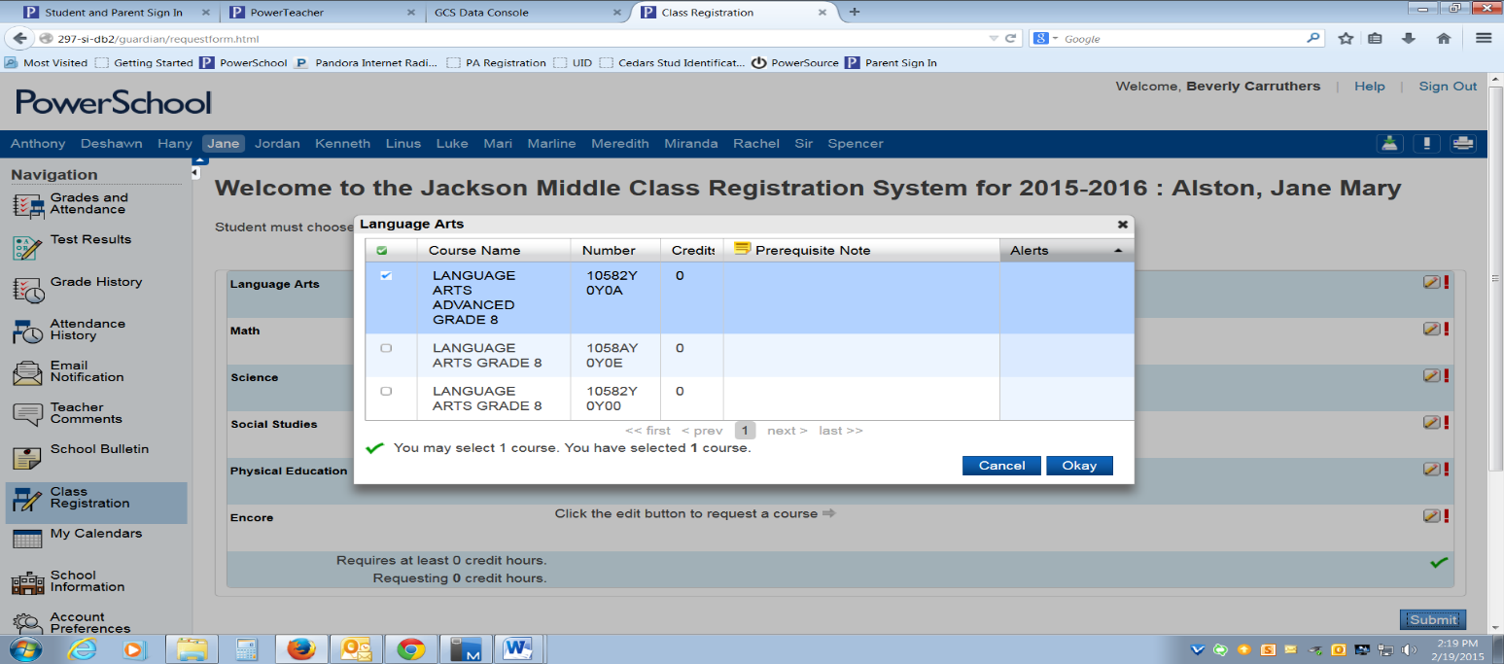

**Feb 14-23 -** Online Registration Window opens for all

students to choose their Encore requests**.**

**\***Students should log on to PowerSchool to choose

courses. Notes/directions are made under each course

selection, please read and follow all directions carefully.

*Choose Math and ELA courses based on current

performance. Final Math and ELA placements will be made

over the summer based on all available data.

*6th Grade Encores – Band, Orchestra, Theater, Chorus, Art,

Digital Art, CS Discoveries, Computer Skills, Exploring

Nutrition, Exploring Technology, Exploring Careers

*Encore requests are NOT guaranteed, they are based on

enrollment numbers and availability.

*Encore course descriptions are available in the online

Registration book – see link on front side of this document.

3.Once courses have been chosen for all subjects, click **SUBMIT**.

Selected Course requests will appear and your counselor can now view the requests.

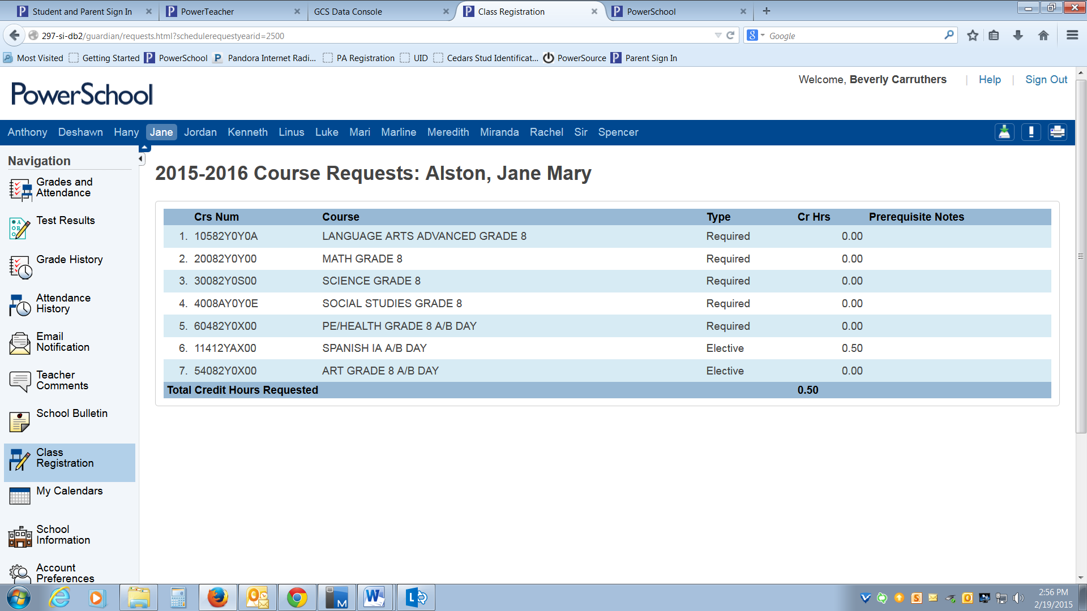

If **‘Submit’** is clicked before the number of courses required are chosen,

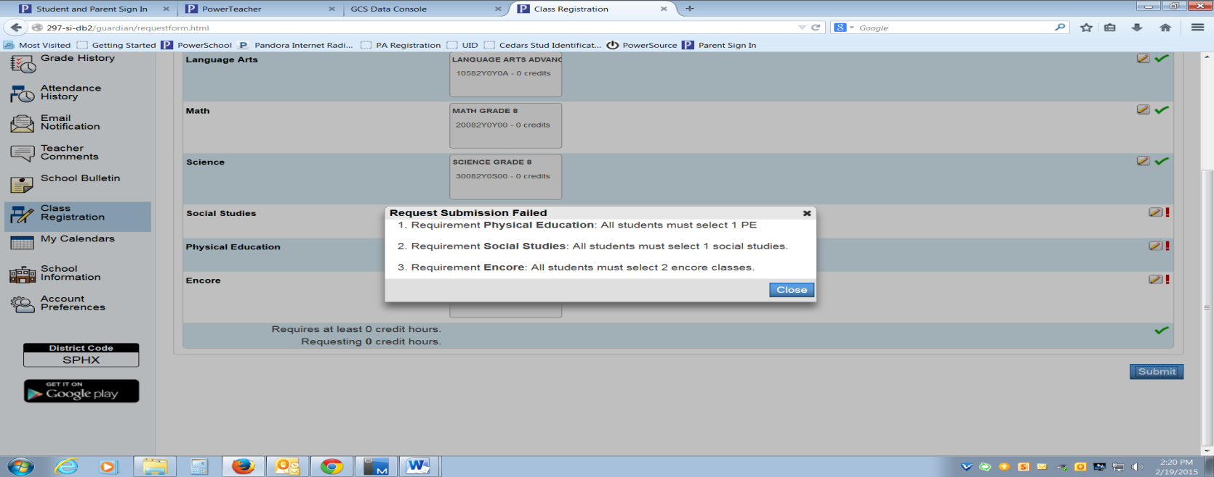 an error message appears.

Close the error message and the system will return to the first screen.

Follow the steps above until the appropriate amount of courses are chosen.