Modern History Sourcebook:   
Tables Illustrating the Spread of Industrialization EQ: How did different types and locations of production develop and change over time? U 5.4

**Table 1**

**Percentage Distribution of the World's Manufacturing Production,**

**1870 and 1913**

(*percentage of world total*)

|  |  |  |
| --- | --- | --- |
|  | **1870** | **1913** |
| **USA** | 23.3 | 35.8 |
| **Germany** | 13.2 | 15.7 |
| **U.K.** | 31.8 | 14.0 |
| **France** | 10.3 | 6.4 |
| **Russia** | 3.7 | 5.5 |
| **Italy** | 2.4 | 2.7 |
| **Canada** | 1.0 | 2.3 |
| **Belgium** | 2.9 | 2.1 |
| **Sweden** | 0.4 | 1.0 |
| **Japan** |  | 1.2 |
| **India** | 11.0 | 1.1 |
| **Other Countries** |  | 12.2 |

**Table 2**

**The Rate of Industrial Growth in Five Selected Countries**

**Indices of Industrial Production**

(Base Figures - 1905-13 = 100)

|  |  |  |  |  |  |
| --- | --- | --- | --- | --- | --- |
|  | **UK** | **France** | **Germany** | **Russia** | **Italy** |
| **1781-90** | 3.8 | 10.9 | - | - | - |
| **1801-14** | 7.1 | 12.3 | - | - | - |
| **1825-34** | 18.8 | 21.5 | - | - | - |
| **1845-54** | 27.5 | 33.7 | 11.7 | - | - |
| **1865-74** | 49.2 | 49.8 | 24.2 | 13.5 | 42.9 |
| **1885-94** | 70.5 | 68.2 | 45.3 | 38.7 | 54.6 |
| **1905-13** | 100.0 | 100.0 | 100.0 | 100.0 | 100.0 |
| **% of world industrial production in 1913** | 14.0 | 6.4 | 17.7 | 5.5 | 2.7 |

**Table 3**

**Growth of the Cotton Industry in Selected Countries**

(Cotton Spindles - Selected Countries, Annual Total Figures [in 1000's])

|  |  |  |  |  |  |  |
| --- | --- | --- | --- | --- | --- | --- |
|  | **UK** | **France** | **Germany** | **Austria** | **Belgium** | **Russia** |
| **1834** | 10,000 | 2,500 | 626(`36) | 800 | 200 | 700 (1840) |
| **1877** | 39,500 | 5,000 | 4,700 | 1,558 | 800 | 2,500 |
| **1913** | 55,700 | 7,400 | 11,186 | 4,909 | 1,492 | 9,212 |

Table 4

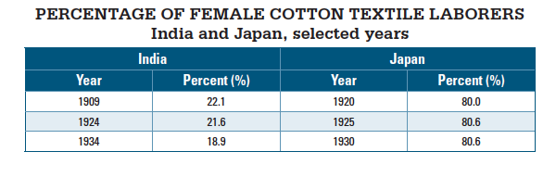

Table 5

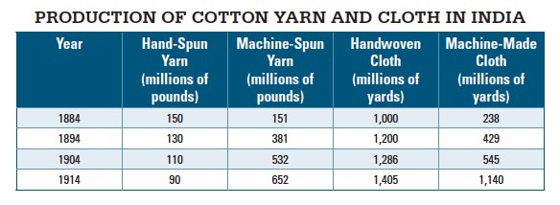

**Document 6**

Source: Tsurumi Shunsuke, Japanese industrialist, circa 1900.

Where do the cheap workers come from? They all come from farming communities. People from families that are working their own land, or are engaged in tenant farming but have surplus workers, come to the cities and the industrial centers to become factory workers. Income from the farms provides for the family needs and subsistence of the parents and siblings. The person who takes employment in the factory is an unattached component of the family. All he or she has to do is earn enough to maintain his or her own living. That is why the workers’ wages are low. This shows how important a force agriculture continues to be for the development of our nation’s commerce and industry.

**Document 7**

Source: Radhakamal Mukerjee, Indian economist, The Foundation of

Indian Economics, 1916.

For the last few decades there has been a rapid decline of the handwoven cloth industry throughout the country on account of the competition of machine manufactures. Though many still wear clothing made from cloth woven on handlooms, large numbers of handloom weavers have been abandoning their looms. The local textile industry owes its very existence, promotion, and growth to the enterprising spirit of native bankers and investors, who invest large capital as shareholders, investors, and financiers.