**Chapter #: Title**

____

____

____

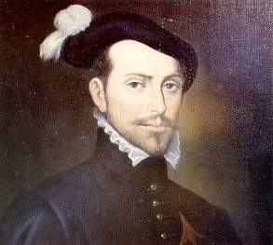

______

____

____

Hernan Cortes

____

____

____