AP European History OPTIONAL Summer Reading:
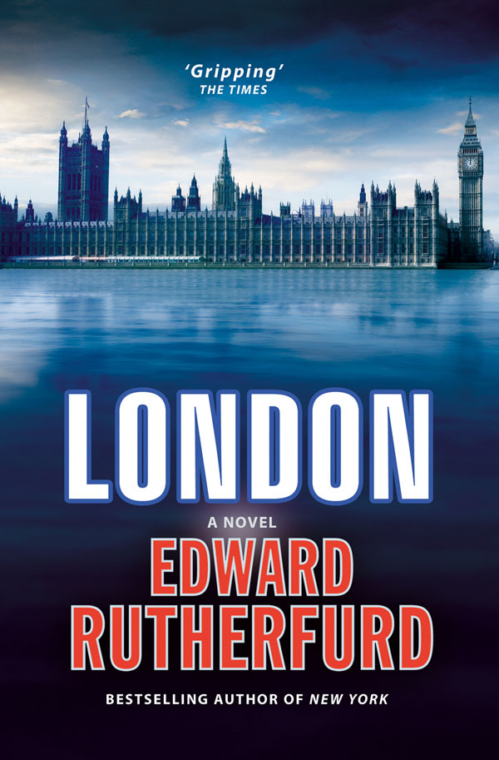
LONDON (1997) by EDWARD RUTHERFURD

❖ Check used books stores like EDWARD Mc KAY’s
on Battleground Ave. It is also available at BARNES
& NOBLE in Friendly Center. You will also be able to
find a copy at your local Library. It is available at
Amazon.com new (& used as little as $3-4!) It is
also available in e-book format.

This Historical novel is a segmented account of
the development of the English city of London,
from its earliest beginnings as a Roman town
and continual growth , through the rebuilding of
the city after the 1666 Great Fire and it’ second reconstruction after the Nazi Blitz during World War II. All these events are seen through the eyes of several original families of London, through multiple generations.

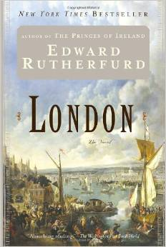
Each Chapter is a different time period, with some chapters being more interesting than others. This is a pretty lengthy book (1,000+ pages) and though it would be great to read it all. Most students typically read segments they are interested in the time period topic. I would suggest the following chapters are the most interesting: 11, 13, 15, 17, 18, 19 & 20. ☺

There is a short assignment that can be
Picked up the first few weeks of school,
to enable you credit for reading this
in whole or in part over the summer.

HAVE A GREAT SUMMER ☺

MS. POLLOCK

AP European History OPTIONAL Summer Viewing. ☺
Here are a few suggested films to watch over the summer to prep for AP European History.

A) The Lion In Winter (1968) England’s Henry II & Eleanor of Aquitaine’s dysfunctional family
B) The Messenger (1999) The story of Joab D’Arc during the Hundred Years War in France
C) 1492-Conquest of Paradise (1992) Columbus’s journey to the Americas
D) Lady Jane (1986) England in crisis for a Protestant heir to the throne, as young Edward VI is dying of TB
D) Elizabeth (1998) The early struggles on the throne of England of Queen Elizabeth I
E) The Girl With The Pearl Earring (2003) Servant girl in the home of Dutch painter Vermeer
F) Amazing Grace (2006) British abolitionist Wilberforce struggles to end the Slave Trade
G) Marie Antoinette (2006) The life of France’s last Bourbon Queen on the eve of revolution
H) Restoration (1995) Charles II is restored to the English throne in a time of transition
I) Young Victoia (2009) Young 18 year old Victoria becomes Queen of the British Empire
J) War Horse (2011) Set in England & France during WWI, follows the experiences of a warhorse
K) Suffragette (2015) Women ban together in the early 1900’s Britain to demand the vote
L) Swing Kids (1993) Pre-WWII Germany, teens are “swing kids” by night & Hitler Youth by day
M) Darkest Hour (2017) Churchill becomes Britain’s new PM as the country teeters toward WWII
N) Hope & Glory (1987) London families experience the Blitz in the early years of WWII
O) The Imitation Game (2014) Struggle to develop a cod- breaking machine to thwart Nazis
P) Valkyrie (2008) German officers plot and attempt to assassinate their leader Adolf Hitler
Q) The Monuments Men (2014) American special forces hunt art work stolen by the Nazis at the end of WWII
R) Bridge of Spies (2015) The exchange of US & USSR spies in Cold War Berlin
S) Woman In Gold (2015) Austrian exile wants to reclaim families art stolen from the Nazis

 This list does include PG-13 & R rated films, since this is an optional assignment, please let parent/ guardian know you do have OPTIONS and are NOT REQUIRED to watch films that they may deem not appropriate. Choose films wisely. ☺

Assignment : Watch 2-4 films listed above.
PART I - While watching to the following. Take bulleted notes of the events in the movie. This should typically be some 20ish + bulleted statements of the plot twists and turns throughout the course of the film.
PART II – After watching the film, using college rule, notebook paper write out the following information:
- 1- Film Name & Year 2- List of major characters with brief description (+ actor’s name) 3- Historical Time & Place 4- Brief Summary of the main plot; answering: What is this film about?
- Using your film notes from Part I. Trace the major events & turning points of the
film. This is to be formatted as a complete sentence, bulleted list. (ex. :   ⇨ … )

 Upon your arrival to class in August you will be given instructions on how
to submit assignment. It is not due first day of class. ☺

