Materials for All Band Students
- Access to the Internet with powerpoint and pdf applications
- A Working Instrument
Method Books
- Standard of Excellence Book 1 for your instrument (Red Book) 6th GRADE
- Standard of Excellence Book 1 for your instrument (Blue Book) 7th GRADE and 8th GRADE

Book 1 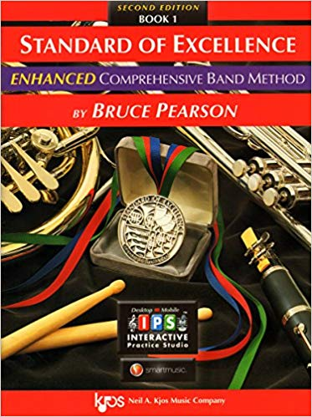 Book 2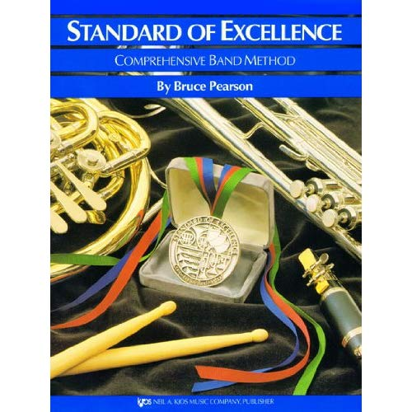
Optional Materials
- Tuner
- Metronome
- Recorder
There are many free apps as well as apps that cost money for Tuners, Metronomes and Recorders. Many of the apps have all three combined.

Donating Materials for Band We Need
- Paper
- Pencils
- Kleenex
- Hand Sanitizer
- Mouthpiece spray
- Size 2.5 or 3 Rico or Vandoren Clarinet/Bass Clarinet Reeds
- Size 2.5 or 3 Rico or Vandoren Alto/Tenor Saxophone Reeds

