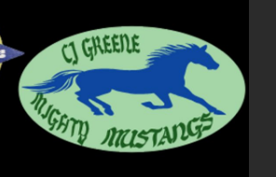LAVENDER** **YELLOW** **HOT PINK**  **BROWN** **ORANGE** **LIGHT GREEN POP SOCKETS ($2)**

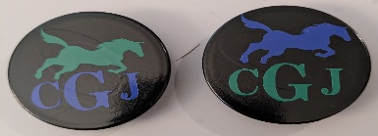

**TURQUOISE**  **NEON GREEN ARMY GREEN**  **KELLY GREEN**  **PURPLE** **BURGUNDY**

**TEMPLATES FOR HATS (WHITE OR BLUE)**

**RED** **KHAKI** **DARK GRAY** **GOLD** **HUNTER GREEN** **ROYAL BLUE**

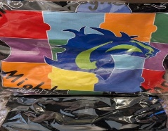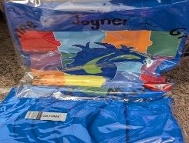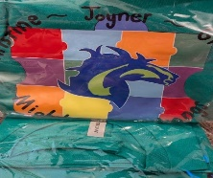

**WHITE** **NAVY BLUE**   **BLACK** **PINK** **LIGHT BLUE** **LIGHT GRAY**

**TEE HATS W/TEMPLATE ($10) ADD YOUR NAME ON THE BRIM ($2) SHIRTS**

**WHITE GREEN BLUE BLACK**

**(S-XL=$15 & 2XL-4XL=$18)**

| **Name:** | |  |  | CJ Greene PTA Merchandise Invoice | | | | | |
| --- | --- | --- | --- | --- | --- | --- | --- | --- | --- |
| **Phone#:** | |  |  | **Date:** | | | | | |
| **Description *(for hats choose white or blue mustang template)*** | | | | **Quantity** | **Color** | **Size** | **Unit Price** | **Total** | |
|  | | | |  |  |  |  |  | |
|  | | | |  |  |  |  |  | |
|  | | | |  |  |  |  |  | |
|  | | | |  |  |  |  |  | |
|  | | | |  |  |  |  |  | |
|  | | | |  |  |  |  |  | |
|  | | | |  |  |  |  |  | |
|  | | | |  |  |  |  |  | |
|  | | | |  |  |  |  |  | |
|  | | | |  |  | Subtotal  Customized (hats only)  Shipping & Handling |  |  | |
|  | | | |  |  |  |  | |
|  | | | |  |  |  |  | |
|  | | | |  |  | Total Due |  |  | |

**Tel** (336) 454-7445/ **Alt** (336) 823-4601 604 E. Main Street, Jamestown, NC 27282 sheilalooney@rocketmail.com or harrisj@gcsnc.com