
“A MIND IS LIKE A PARACHUTE, IT DOESN’T WORK IF IT IS NOT OPEN.”-Frank Zappa
7TH GRADE MATH SYLLABUS

Welcome to 7th Math! My name is Ms. McZeek and I am thrilled to have the opportunity to work with your student at Allen Middle School during the 2018-2019 school year. I graduated from NCA&TSU in 2000 with my bachelor’s degree in Applied Mathematics and currently working on a degree in Business Education. I am excited to see what this year will bring! Please keep reading to learn more about my classroom policies.
  mczeekk@gcsnc.com  This Photo by Unknown Author is licensed under CC BY |   336-294-7325 ext.1602 |   I will set up a student and parent remind. To Communicate via text message.
GRADING SCALE POLICY  Homework 5%  Classwork 30%  Quizzes 25%  Test/Project 40% | 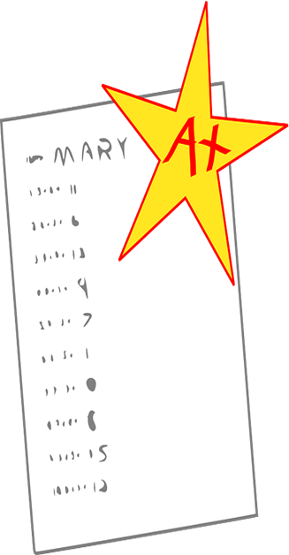 | We follow Guilford County’s Grading Policy:  90-100 = A  80-89 = B  70-79 = C  60-69 = D  59 or lower = F
CLASS EXPECTATIONS AND CONSEQUENCES
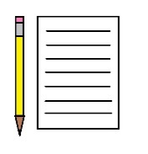  Classroom Expectations:  - Here are my non-negotiables:  - Being on time for class with materials ready.  - Do not take or touch other peoples’ things without first asking permission.  - Showing kindness & respect to oneself, others, and all teachers and personnel at Allen Middle School.  - Adhere to all Guilford County and Allen Middle School policy and procedures  - A willingness to try, make mistakes, share experiences, and learn! |  | Consequences  Behavior  - 1st offense = Verbal Warning  - 2nd offense = Parent contact made and silent lunch  - 3rd offense = Student/Teacher/Parent/Administrator group conference  - 4th offense = After School Detention  - 5th offense = Referral to principal  Tardies:  - 3 tardies = Silent lunch & parent contact  - 6 tardies = After school detention & parent contact  - 9 tardies = Referral to principal & parent contact
Cell Phone Policy  - Cell phones should be secured-not seen (in pockets, print), viewed in use or heard  - 1st offense is a 24 hour hold  - 2nd offense is a 48 hour hold  - 3rd offense is a 72 hour hold  Parents will have to retrieve from the front office |  | Locker Policy and Transition Times  - Every child will receive a locker and a lock. If lock is lost they are responsible for replacing. Transition times will be discussed first week of class.
My homework policies & philosophies:
- I give homework as a means of assessing previously learned skills. It will be graded daily.
- I will give homework out 2-3 times per week.
- Homework will not be assigned on Fridays unless needed.
- There will be quarterly notebook checks for classwork.

Missed work due to absences:  - I give students 3 days to collect and turn in missed work. When a child is absent for more than one day, their time is extended by 1 day for every day missed.  - Full credit is given to missed work for absences.   |  | Turning in late work:  - If a student does not turn in homework on time, they are given 2 days to turn in work for full credit.  - When work is not turned in within that time frame, students can turn work in late knowing their starting grade will be at 70% for that assignment.
Lenovo Notebooks -will be used daily in Math. The class assignments, projects, and assessments will be completed digitally through Canvas and our compostable notebooks. Students are expected to abide by all school and district digital safety rules and guidelines. Failure to do so will result in said student being banned from technology while in Math Class. Partaking in activities on the tablet that are not appropriate during class time will result in loss of tablet privileges. This means no games, movies, music videos, etc. during instructional time.
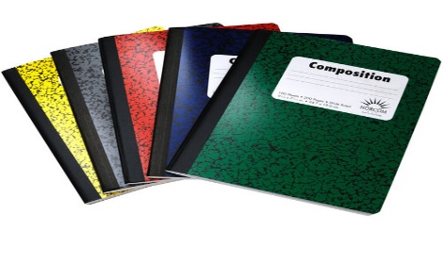
The only materials your child needs to succeed in my class are:
- 1 BLUE single composition (per semester)
- Plenty of pencils!!
- 1 pack Graphing Paper
- Earbuds
- Hand sanitizer/ tissue

I look forward to this school year! I want you to be on my team! (cut below, sign, date and return)

----------------------------------------------------------------------------------------------------------------
I have read and understand the rules and expectations for class. I acknowledge that it is my responsibility to contact my teacher if I have any questions or concerns. I know that the syllabus, assignments, calendar, and resources are available to me at any time. I understand the rules, and expectations that Ms. McZeek has set forth.

Student Signature___________________________ Date_____________

Parents Signature____________________________ Date_____________

